Technical Documentation

Version 1.0

Contents

1 Document Control 1

1.1Document History 1

1.2Supporting Documents 2

2 Introduction 3

2.1Definition Acronyms and Abbreviations 3

3 Solution Architecture 4

3.1Technology Stack for Microservices 4

3.2System Application Design 4

4 Architecture Design and Configuration 4

4.1 Azure Infrastructure & DevOps Setup 4

4.2Database Design and Setup 4

5 SpiTech API Specifications 5

5.1Overview of API 5

5.2Authentication 5

5.3Pay at Pump 5

5.3.1 Login 5

5.3.2 Home Screen 6

5.3.3Add Payment Method 7

5.3.4 Signal R Connections for Pay at Pump 8

5.3.5Transaction and Cash Reward History 9

5.3.6User Profile 10

5.3.6App Settings 11

5.4Pay in Store 12

# Document Control

## 1.1 Document History

|  |  |  |  |
| --- | --- | --- | --- |
| Date | Version | Author | Comments |
| 2nd Jul, 2024 | Initial Draft | Sunil Singh |  |
|  |  |  |  |
|  |  |  |  |

## 1.2 Supporting Documents

|  |  |  |
| --- | --- | --- |
| Document | Location | Owner |
|  |  |  |
|  |  |  |
|  |  |  |

# **Introduction**

The purpose of this document is to define the specific technology design and configuration for the technology components of the **SPITECH** **Mobile App**. This document is intended for use by the members of the designated Development and Technical Operations team. It is intended that this document captures the solution design details pertaining to the deployment of technology in question as well as configuration build details.

## 2.1 Definition Acronyms and Abbreviations

|  |  |
| --- | --- |
| Terms | Description |
| DCR | Comment or defined Mitigation for the risk. |
| PFEP | Payment Front End Processor- the application or institution that the Site or MPPA uses for the processing of payments. |
| Site System | Site System – site equipment and components (hardware and software) including, but not limited to, POS, EPS, FD, and FDC. |
| MPA | Mobile Payments Application - a software application downloaded by a customer to a mobile device to facilitate mobile payment transactions. |
| MPPA | Mobile Payments Processing Application - the application/host that facilitates the communication between the MPA on the mobile device, Site System, and at times the PFEP for purposes of mobile payments. |
| UMTI | Unique Mobile Transaction Identifier. The UMTI serves as a transaction identifier. It is expected that the UMTI will remain the same for all the messages exchanged for a single transaction. |
| ASA | Above Site Authorization. |
| STAC | Single Transaction Authentication Code. |
| Consumer | SPITECH Mobile App User |
| AKS | Azure Kubernetes Service |
| **Resource Type** | An abbreviation for the Azure Resource Type of this resource. Such as vm, sql, aks. |
| **Environment** | The application lifecycle for the workload the resource belongs to; such as Development, UAT, Test, or Production. An example shorter abbreviation of these might be DEV or PRD. |
| APIM | API Management |
| VNET | Virtual Network |
| VM | Virtual Machine |
| IP | IP Address (IPv4) |
|  |  |

# Solution Architecture

## 3.1 Technology Stack for Microservices

* ASP.NET
* Entity Framework
* Azure Services
* Microsoft Identity Server
* SignalR
* RabbitMq
* Swagger / Azure APIM
* SQL Server
* SEQ

## 3.2 System Application Design

The SpiTechApplication Micro-Services design is based on clean architecture domain driven design, where the application is based on Domain model centric approach.

Application Core is the building blocks not specific to any domain or technology, containing generic building blocks which are reused in multiple applications. It will never include technological concepts.

Domain Model holds all the core entity that controlling the domain through the API

API acts as the entry point to the domain, using terms and objects from the domain. The API should only expose immutable objects to prevent developers from using the exposed objects to gain access to the underlying domain, thus manipulating the domain.

The Application hold the entire business logic and domain validation logic and expose contract to infrastructure to make loose couple design allow to implement logic at infrastructure end.

Infrastructure is the outermost layer containing adapters for various technologies such as databases, user interface, massage broker and external services. It has access all the inner layers but most operations should go through the API, one exception being domain interfaces with infrastructure implementations. This layer contains classes for accessing external resources such as file systems, web services, smtp, and so on. These classes should be based on interfaces defined within the application layer.

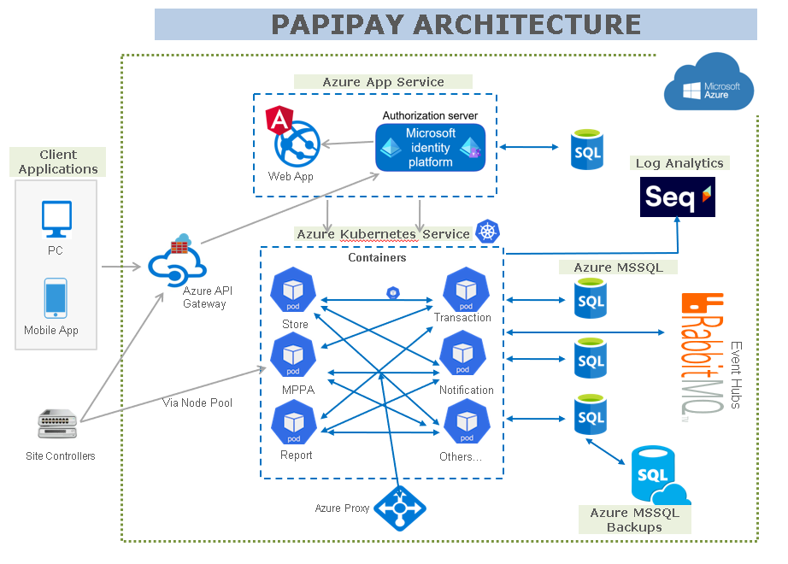

# **Architecture Design and Configuration**

## **Azure Infrastructure & DevOps Setup**

The following services need to be subscribed for the SpiTech Application and Database environment.

**Services**

We have used the below services for SpiTech infrastructure

1. Virtual Network
2. Network Security Group
3. AKS
4. Azure Load Balancer
5. API Management
6. Storage account
7. Azure Container Registry
8. Azure SQL Server
9. Azure Key vault
10. Azure Web App
11. Log analytics workspace
12. Application Insight
13. Rabbitmq
14. SEQ
15. Azure DevOps

**Azure Virtual Networks**

To create an Azure Virtual Network using the Azure Portal:

1. Navigate and sign in to the Azure portal.
2. Select create a resource on the Azure Portal homepage.
3. On the Create a resource page, search the marketplace for virtual networks and select it from the results.
4. On the Virtual Network page, select Create.
5. On the Create virtual network page, configure the information in the Basics tab.
6. Subscription: select the subscription to bill the resource against
7. Resource group: create a new resource group or choose an existing one
8. Name: enter vnet-westus-001
9. Region: select the West US region

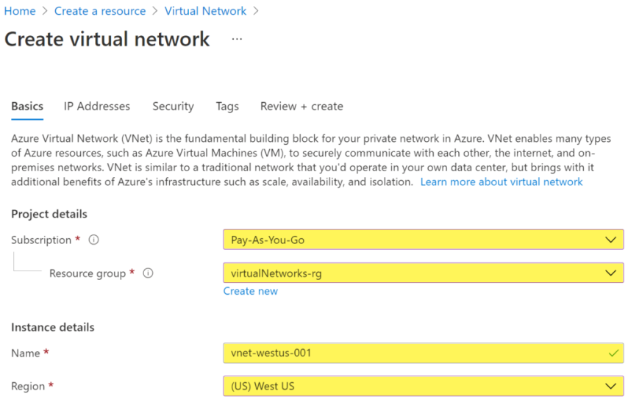

1. Select the Next: IP Addresses button at the bottom of the page.
2. In the IPv4 address space section, Azure has pre-populated the address space 10.1.0.0/16. Select this existing address space and change it to 10.100.0.0/16.
3. If you want to add subnets now, select + Add subnet, then enter the subnet name snet-subnet1 and an address range of 10.50.25.0/24.

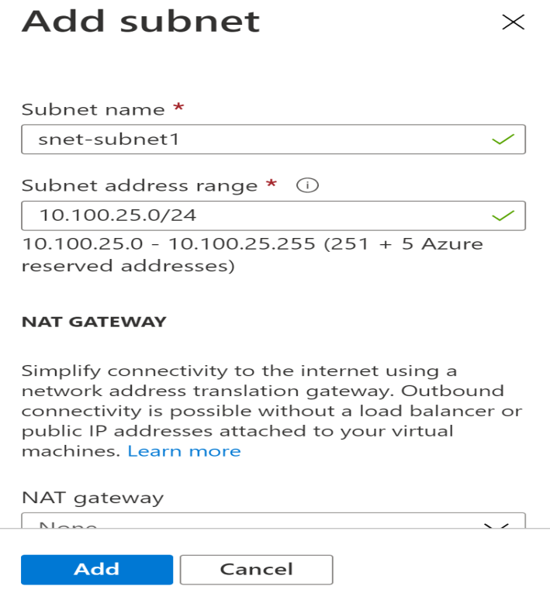

Review the address space and subnets, then select Review + create, then Create after the portal validates the configuration.

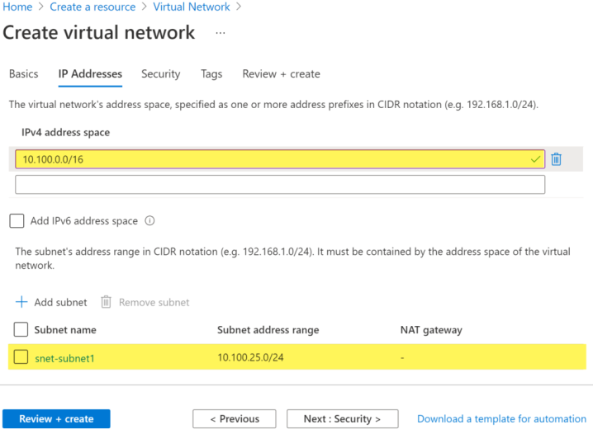

Network Security Group

1. Log in to the Azure portal at https://portal.azure.com.
2. In the top-left corner of the portal, select + Create a resource.
3. Select Networking, then select network security group.

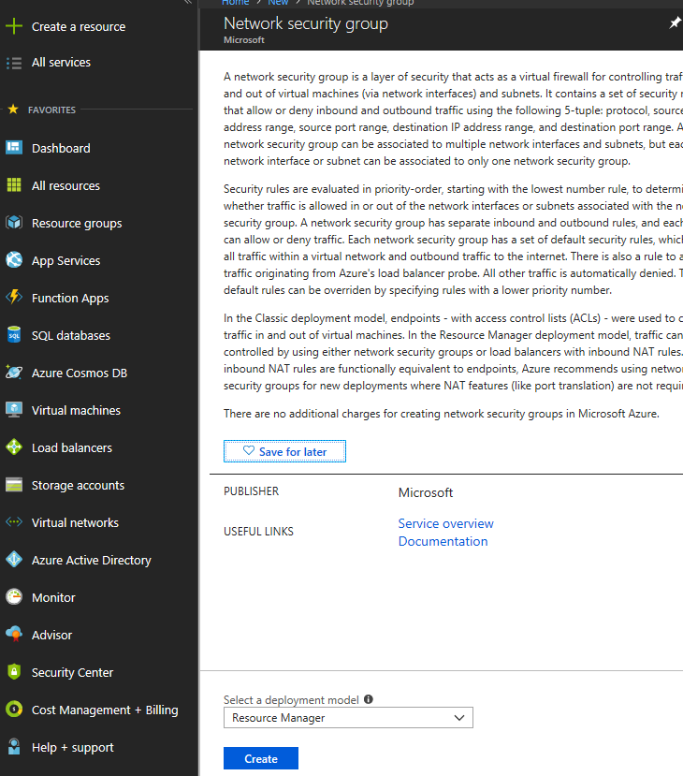

1. Enter, or select, the following information

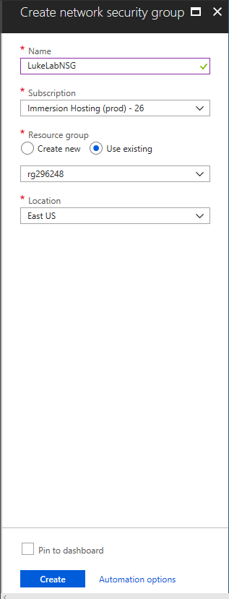

1. Network security group successfully created

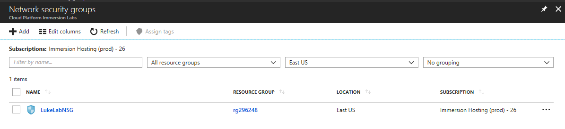

**Associate network security group to subnet**

1. In the Search resources, services, and docs box at the top of the portal, begin typing MyNSG. When MyNSG appears in the search results, select it.
2. Under SETTINGS, select Subnets and then select + Associate

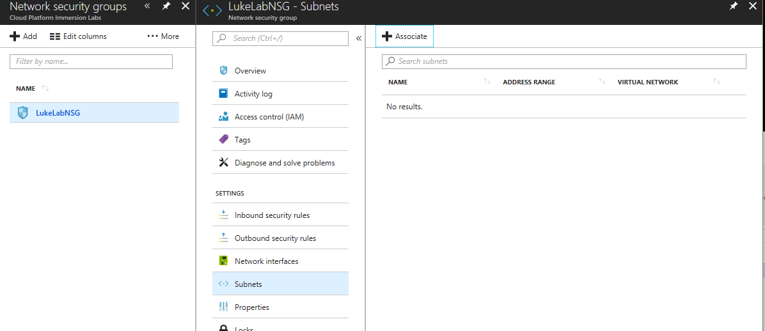

1. Under Associate subnet, select Virtual network and then select MyVNET. Select Subnet, select FrontEndVnet and then select OK.

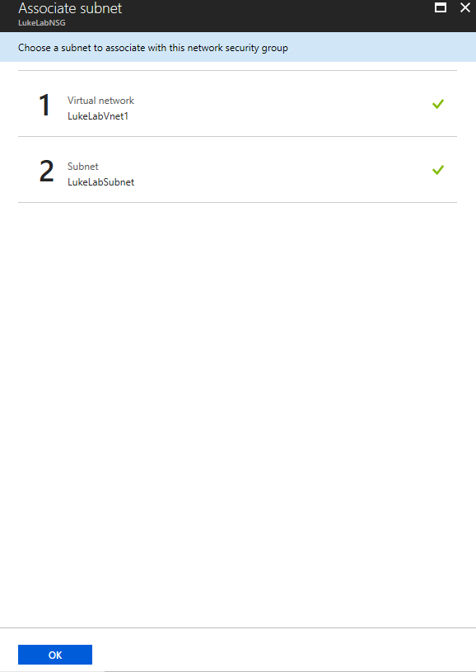

**Create security rules**

1. Under SETTINGS, select Inbound security rules and then select + Add,
2. Create a security rule that allows ports 80, 443 and 3389
3. Under Add inbound security rule, enter the following values

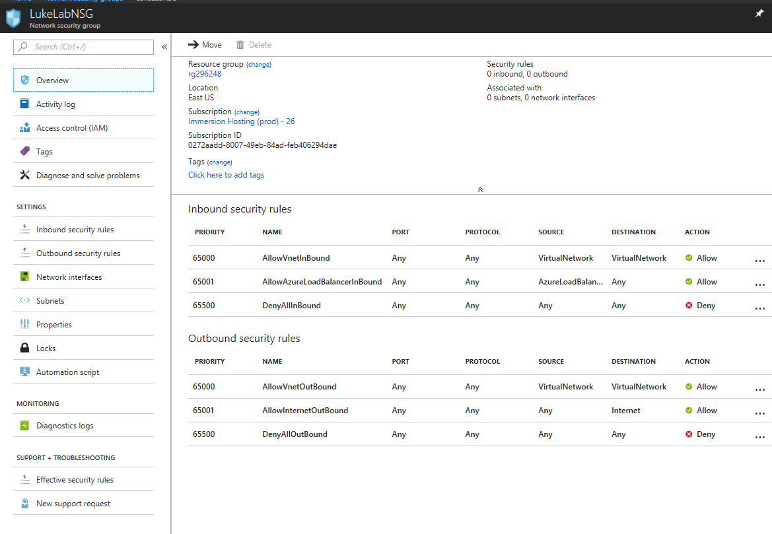

**Create an AKS cluster**

1. Sign in to the [Azure portal](https://portal.azure.com/).
2. On the Azure portal menu or from the Home page, select Create a resource.
3. Select Containers > Kubernetes Service.
4. On the Basics page, configure the following options:
   1. Project details:
      1. Select an Azure Subscription.
      2. Select or create an Azure Resource Group, such as myResourceGroup.
   2. Cluster details:
      1. Ensure the Preset configuration is Standard ($$).
      2. Enter a Kubernetes cluster name, such as myAKSCluster.
      3. Select a Region for the AKS cluster, and leave the default value selected for the Kubernetes version.
      4. Select 99.5% for API server availability.
   3. Primary node pool:
      1. Leave the default values selected.

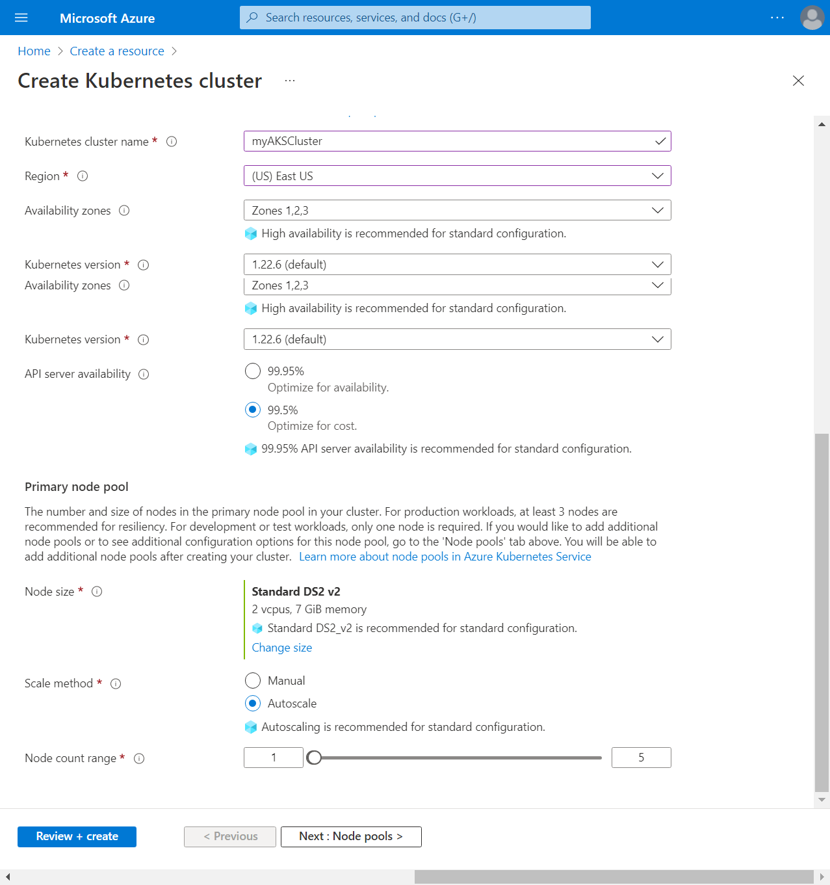

Note: You can change the preset configuration when creating your cluster by selecting Learn more, comparing presets, and choosing a different option.

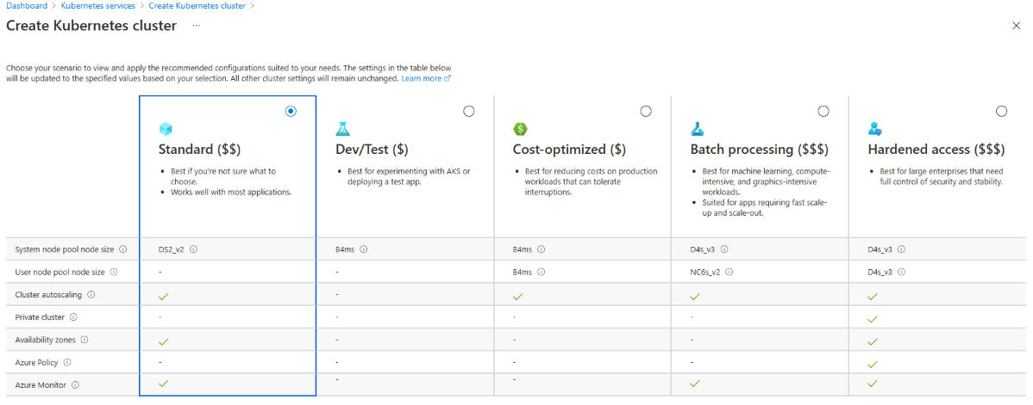

1. Select Next: Node pools when complete.
2. Keep the default Node pools options. At the bottom of the screen, click next: Access.
3. On the Access page, configure the following options:
4. The default value for Resource identity is System-assigned managed identity. Managed identities provide an identity for applications when connecting to resources that support Azure Active Directory (Azure AD) authentication.
5. The Kubernetes role-based access control (RBAC) option is the default value to provide more fine-grained control over access to the Kubernetes resources deployed in your AKS cluster.
6. By default, Basic networking is used, and [Container insights](https://docs.microsoft.com/en-us/azure/azure-monitor/containers/container-insights-overview) is enabled.
7. Click Review + create. When you navigate to the Review + create tab, Azure runs validation on the settings that you have chosen. If validation passes, you can proceed to create the AKS cluster by selecting Create. If validation fails, then it indicates which settings need to be modified.
8. It takes a few minutes to create the AKS cluster. When your deployment is complete, navigate to your resource by either:
9. Selecting Go to resource, or
10. Browsing to the AKS cluster resource group and selecting the AKS resource. In this example, you browse for myResourceGroup and select the resource myAKSCluster.

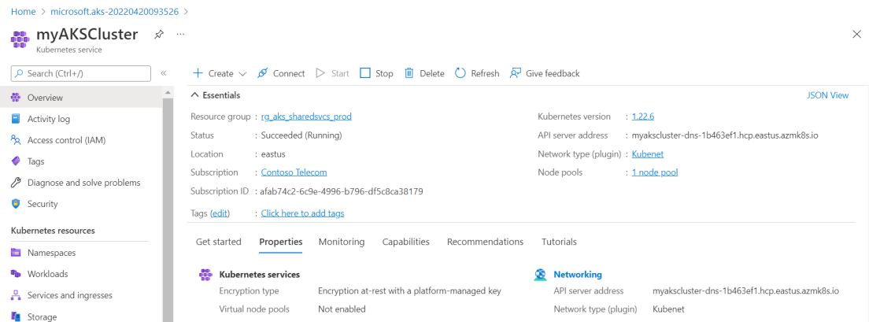

**Azure Load Balancer**

The azure internal load balancer will automatically be created by the AKS when we deploy a service a load balancer type.

Create an API Management service

From the Azure portal menu, select create a resource. You can also select Create a resource on the Azure Home page.

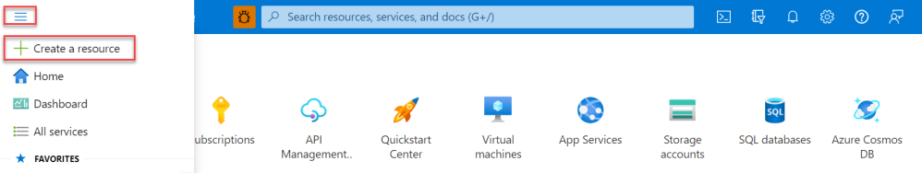

On the Create a resource page, select Integration > API Management.

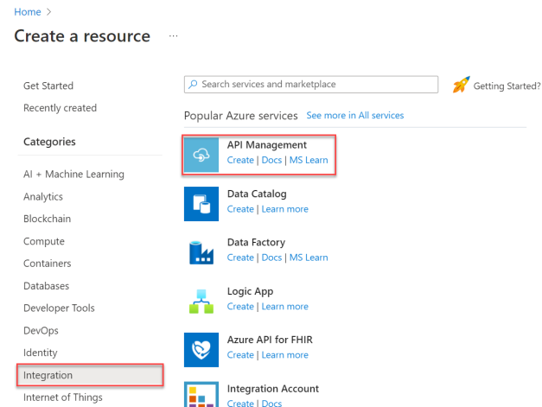

In the Create API Management page, enter settings.

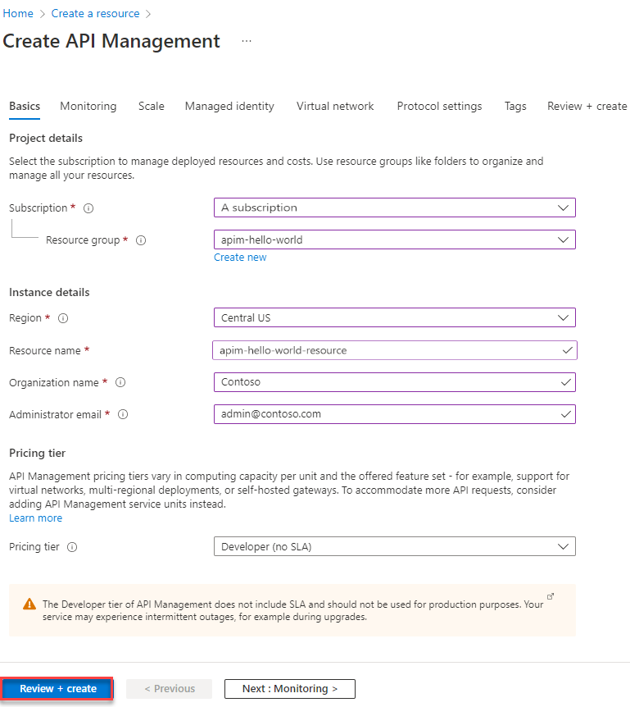

Select Review + create.

Tip: It can take 30 to 40 minutes to create and activate an API Management service in this tier.

#### Import and publish a backend API

This section shows how to import and publish an OpenAPI Specification backend API.

1. In the left navigation of your API Management instance, select APIs.
2. Select the OpenAPI tile.
3. In the Create from OpenAPI specification window, select Full.
4. Enter the values from the following table.  
   You can set API values during creation or later by going to the Settings tab.

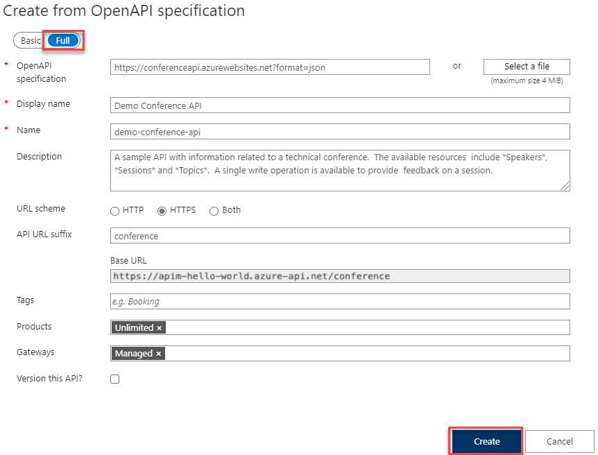

**Create an Azure storage account**

The outlined procedure assumes you have an active Microsoft Azure account.

1. Log in to your Azure account and navigate to the Home page.
2. Click on the storage accounts link in the left-hand navigation bar to reach the screen.

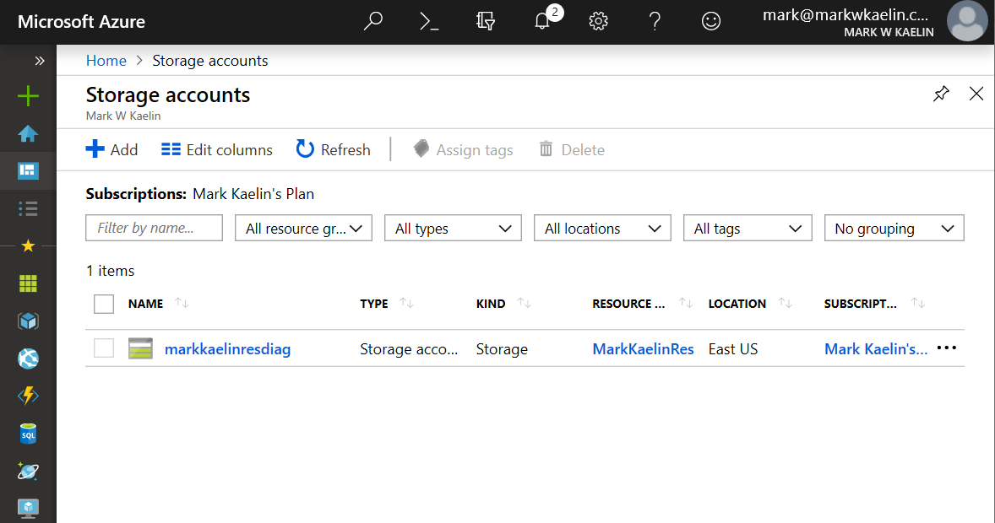

1. Click the + Add button to start a new storage account.
2. Choose the appropriate subscription account and resource group, and then chose a unique name for your new storage account. Remember, you will likely have to type this name to access the storage account, so make it something reasonable.

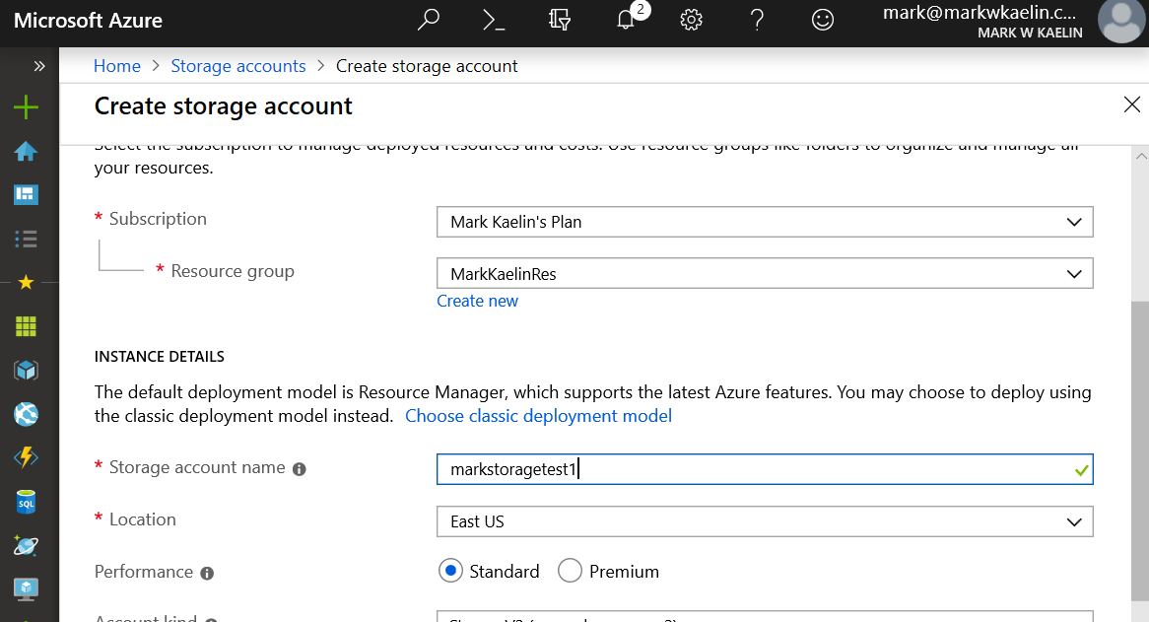

1. Next, choose the location for your server based on your geographical location (closer is better), and then choose a level of service, standard, or premium.
2. The standard setting should be fine for most use cases. For the account kind configuration setting, Microsoft recommends the StorageV2 setting for most applications.
3. Note: StorageV1 is deprecated, and you should only use BlobStorage if your business needs it.

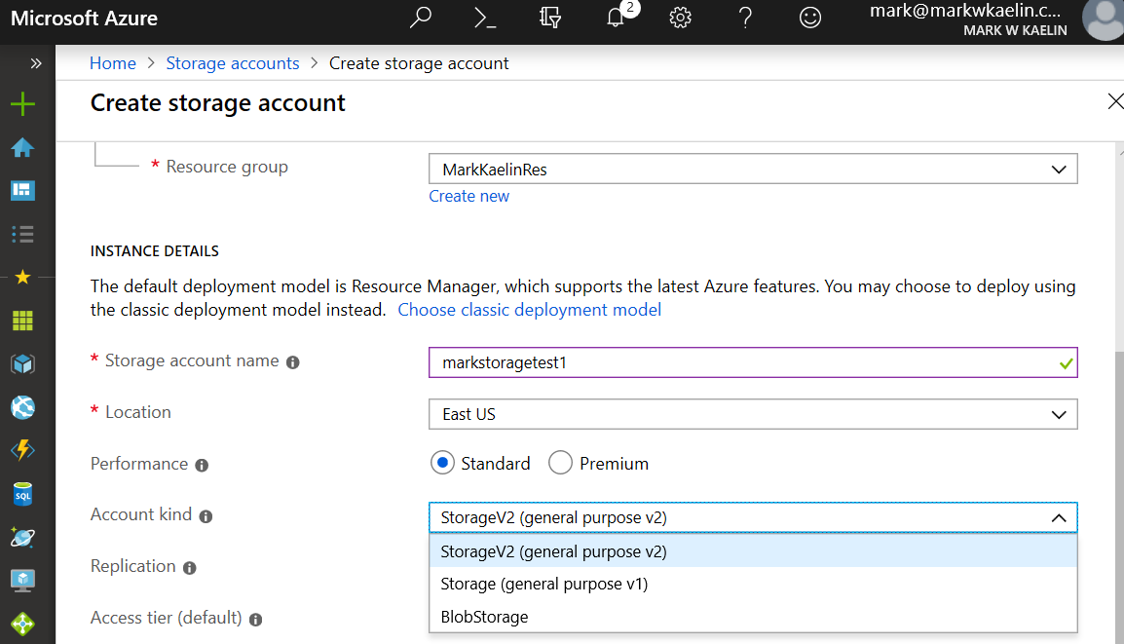

1. The next configuration setting is for replication, and, unlike the previous settings, this decision can tremendously increase the overall cost of your storage account. If the data you will be storing is business-critical and cannot be lost or inaccessible at any time, then you should opt for the more reliable Geo-redundant storage (GRS) setting. If the data destined for your Azure storage account can be replicated from other sources, then the much less expensive Locally redundant storage (LRS) should be chosen.
2. The last setting on the configuration page allows you to choose an access tier. Choose the Hot setting for data that will be accessed frequently. Likewise, choose the Cool setting for data that will be accessed infrequently.
3. When you have made all of your configuration settings click the Review + Create button to move to the next step. You can review your settings (Figure E) before you click the Create button to complete the process.

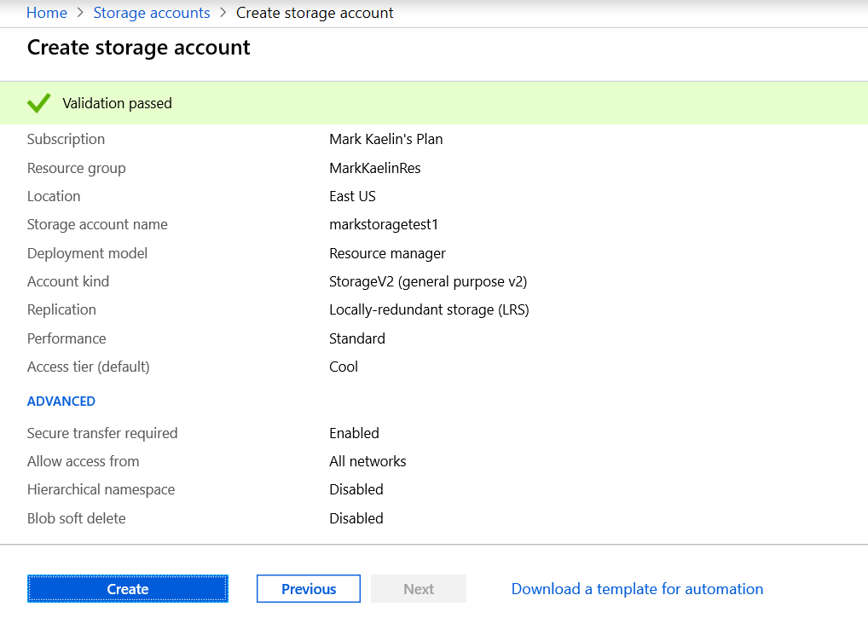

1. Deployment of your new Azure storage account will take a few minutes. When the deployment is complete, you may access your storage account through the Azure Portal.

**Create a container registry**

1. Select Create a resource > Containers > Container Registry.

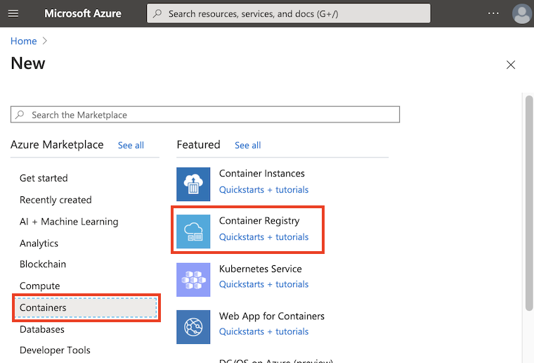

1. In the Basics tab, enter values for the Resource group and Registry name. The registry name must be unique within Azure and contain 5-50 alphanumeric characters. For this quickstart create a new resource group in the West US location named myResourceGroup, and for SKU, select 'Basic'.

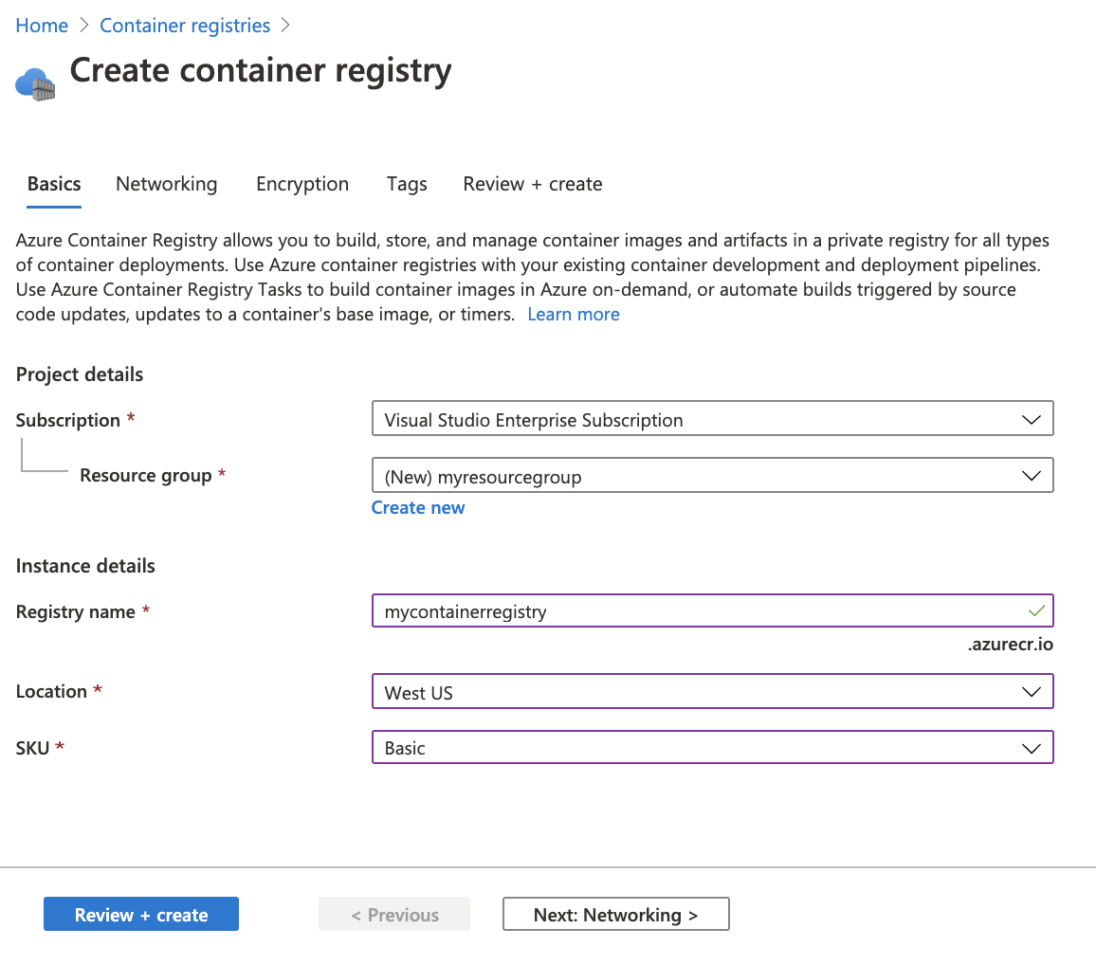

1. Accept default values for the remaining settings. Then select Review + create. After reviewing the settings, select Create.

Tip: In this quickstart, you create a Basic registry, which is a cost-optimized option for developers learning about Azure Container Registry. Choose other tiers for increased storage and image throughput, and capabilities such as connection using a private endpoint.

**Creating Azure Key Vault**

The following shows how to create the Azure Key Vault.

1. Search for Key Vault in the Azure portal and then select Key vaults in the results.

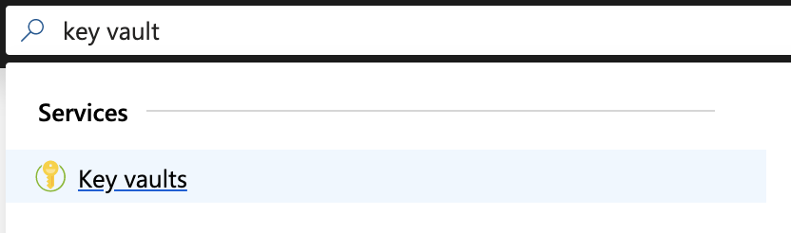

1. Click Add.
2. In the Create key vault section, enter the name for the Key Vault. In this example, create the key vault for the Root CA and use the name EJBCARootKeyVault. Note the name down since it will be required in EJBCA when creating a Crypto Token in the next step [Creating an Azure Key Vault Crypto Token in EJBCA](https://doc.primekey.com/ejbca-cloud/ejbca-cloud-azure/azure-key-vault-integration-guide/creating-an-azure-key-vault-crypto-token-in-ejbca). Then specify the same Resource Group that the EJBCA Instance uses.

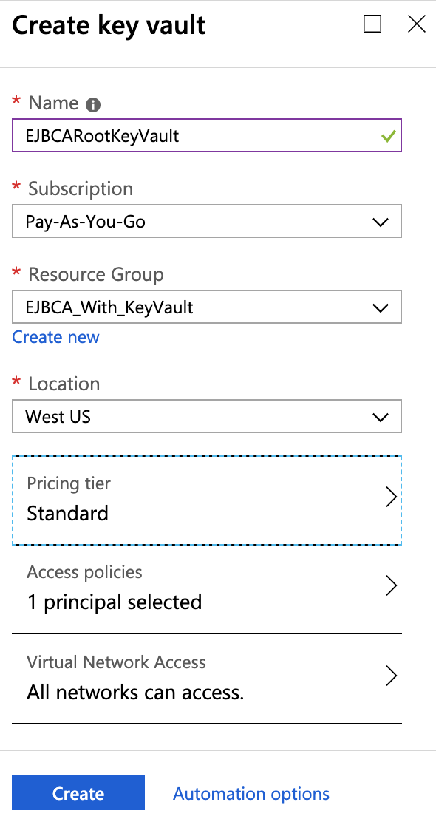

1. Under the Pricing tier, there are two options, Standard and Premium. It is recommended to choose Premium and then click Select.

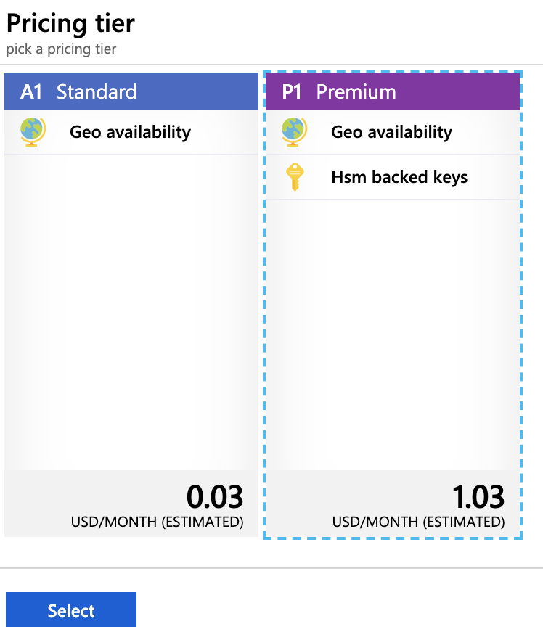

1. Click Access Policies from the Create Key Vault dialog, and then click Add new.

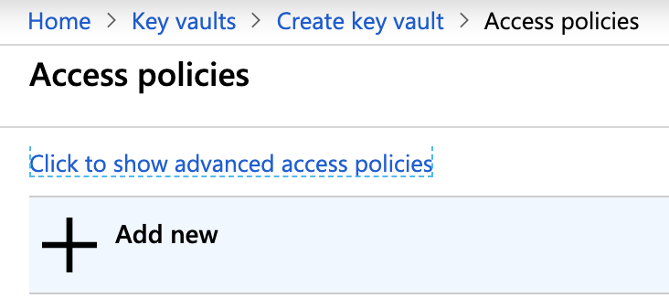

1. Select Key Management from the Configure from the template list.
2. Click Select Principal.

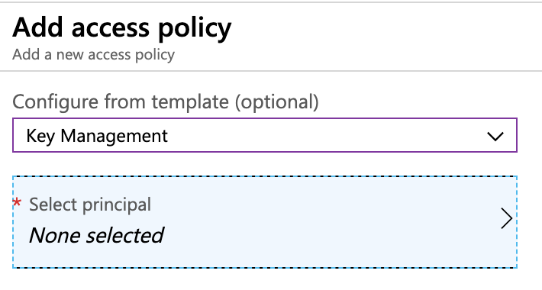

1. Search for the App Registration added in the previous section [Creating an App Registration in Active Directory](https://doc.primekey.com/ejbca-cloud/ejbca-cloud-azure/azure-key-vault-integration-guide/creating-an-app-registration-in-active-directory). In this example, we used the name "ejbca-vault". Select it and click Select.

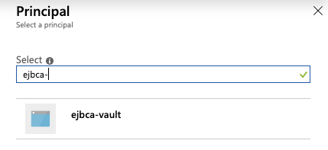

1. Select Key Permissions.
2. Select all of the permissions under Cryptographic Operations.

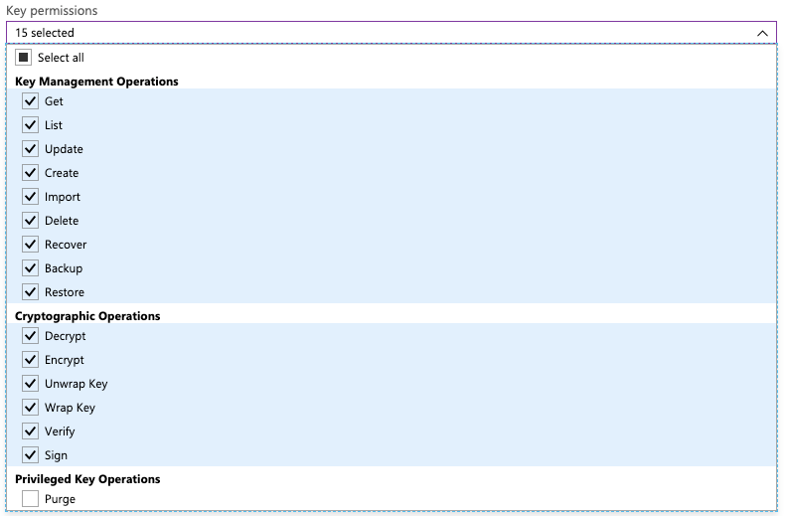

1. Click Add on the Add access policy screen.
2. Click OK on the Access Policies screen.
3. Click the Virtual Network Access section.

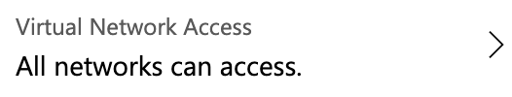

1. Select to Allow access from Selected networks, and then click Add existing virtual networks.

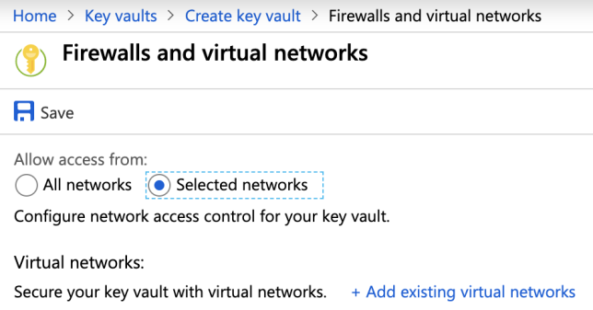

1. From the Virtual networks list, select the virtual network in the resource group that EJBCA Cloud was deployed into. In this example, EJBCA_With_KeyVault-vnet.

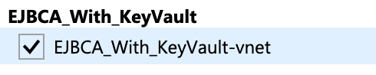

1. Click Select All under Subnets.

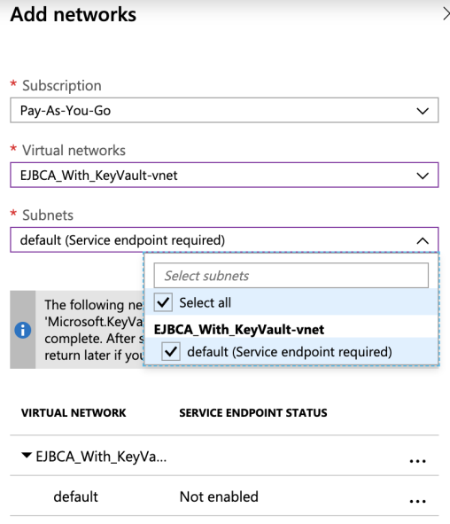

1. Once completed, click Add and then click Save.

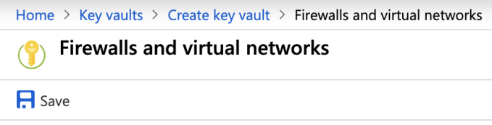

1. Click Create and wait for the deployment to complete.

**Create a single database**

To create a single database in the Azure portal, this quickstart starts at the Azure SQL page.

1. Browse to the [Select SQL Deployment option](https://portal.azure.com/#create/Microsoft.AzureSQL) page.
2. Under SQL databases, leave Resource type set to Single database, and select Create.

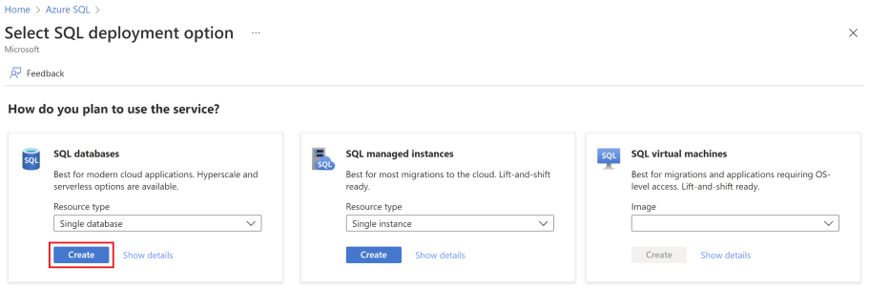

1. On the Basics tab of the Create SQL Database form, under Project details, select the desired Azure Subscription.
2. For Resource group, select Create new, enter myResourceGroup, and select OK.
3. For the Database name, enter my sample database.
4. For Server, select Create new, and fill out the New server form with the following values:

**Server name**: Enter mysqlserver, and add some characters for uniqueness. We can't provide an exact server name to use because server names must be globally unique for all servers in Azure, not just unique within a subscription. So enter something like mysqlserver12345, and the portal lets you know if it's available or not.

**Location**: Select a location from the dropdown list.

**Authentication method**: Select Use SQL authentication.

**Server admin login**: Enter azureuser.

**Password**: Enter a password that meets requirements, and enter it again in the Confirm password field.

1. Select OK.
2. Leave Want to use SQL elastic pool set to No.
3. Under Compute + storage, select Configure database.
4. This quickstart uses a serverless database, so leave the Service tier set to General Purpose (Scalable compute and storage options) and set Compute tier to Serverless. Select Apply.

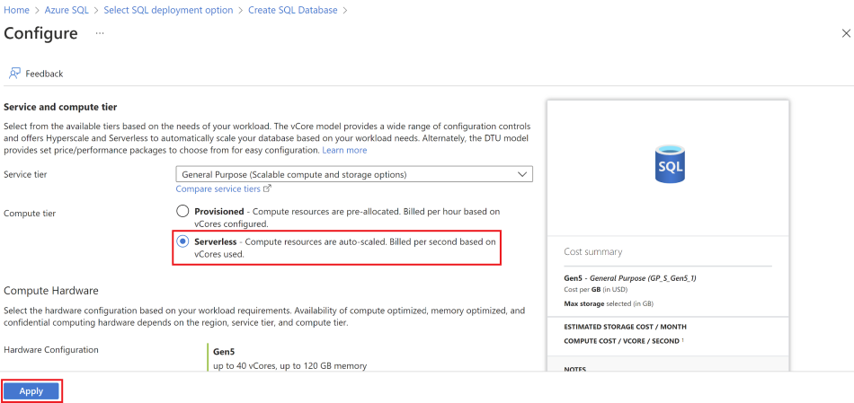

1. Under Backup storage redundancy, choose a redundancy option for the storage account where your backups will be saved. To learn more, see [backup storage redundancy](https://docs.microsoft.com/en-us/azure/azure-sql/database/automated-backups-overview?view=azuresql#backup-storage-redundancy).
2. Select Next: Networking at the bottom of the page.

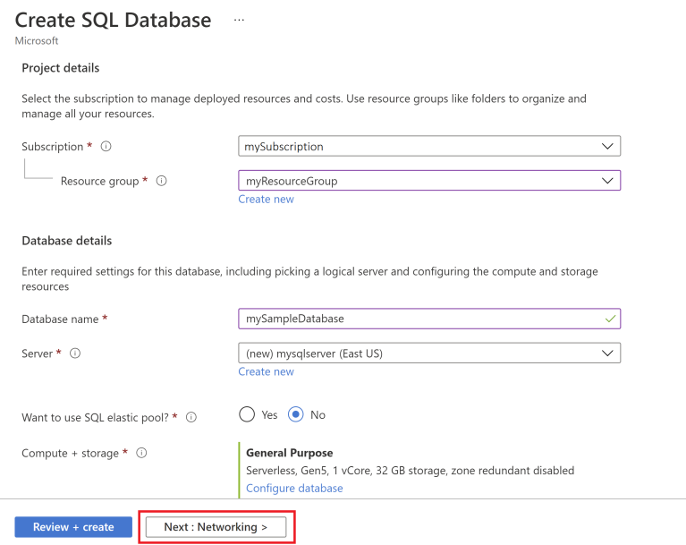

1. On the Networking tab, for the Connectivity method, select the Public endpoint.
2. For Firewall rules, set Add current client IP address to Yes. Leave Allow Azure services and resources to access this server set to No.

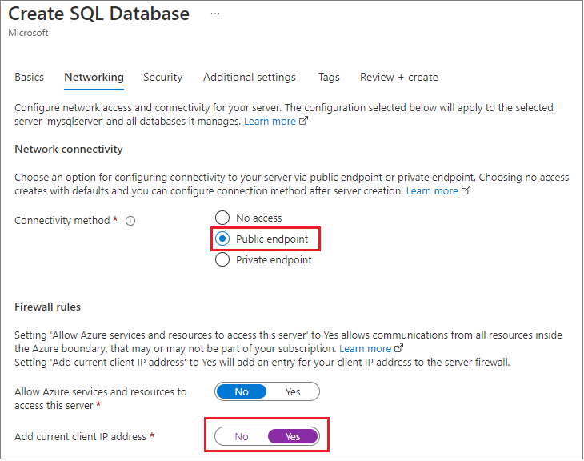

1. Under the Connection policy, choose the Default [connection policy](https://docs.microsoft.com/en-us/azure/azure-sql/database/connectivity-architecture?view=azuresql#connection-policy), and leave the Minimum TLS version at the default of TLS 1.2.
2. Select Next: Security at the bottom of the page.

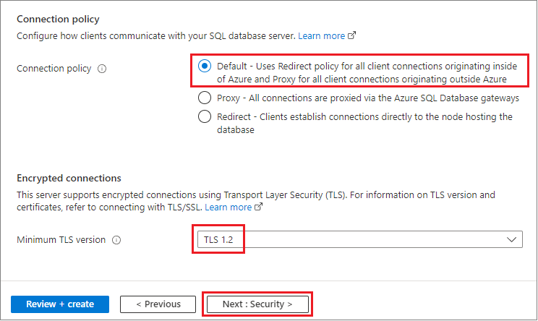

1. On the Security page, you can choose to start a free trial of [Microsoft Defender for SQL](https://docs.microsoft.com/en-us/azure/azure-sql/database/azure-defender-for-sql?view=azuresql), as well as configure [Ledger](https://docs.microsoft.com/en-us/sql/relational-databases/security/ledger/ledger-overview), [Managed identities](https://docs.microsoft.com/en-us/azure/active-directory/managed-identities-azure-resources/overview), and [Transparent data encryption (TDE)](https://docs.microsoft.com/en-us/azure/azure-sql/database/transparent-data-encryption-byok-overview?view=azuresql) if you desire. Select Next: Additional settings at the bottom of the page.
2. On the Additional settings tab, in the Data source section, for Use existing data, select Sample. This creates an AdventureWorksLT sample database so there are some tables and data to query and experiment with, as opposed to an empty blank database. You can also configure [database collation](https://docs.microsoft.com/en-us/sql/t-sql/statements/collations) and a [maintenance window](https://docs.microsoft.com/en-us/azure/azure-sql/database/maintenance-window?view=azuresql).
3. Select Review + create at the bottom of the page:

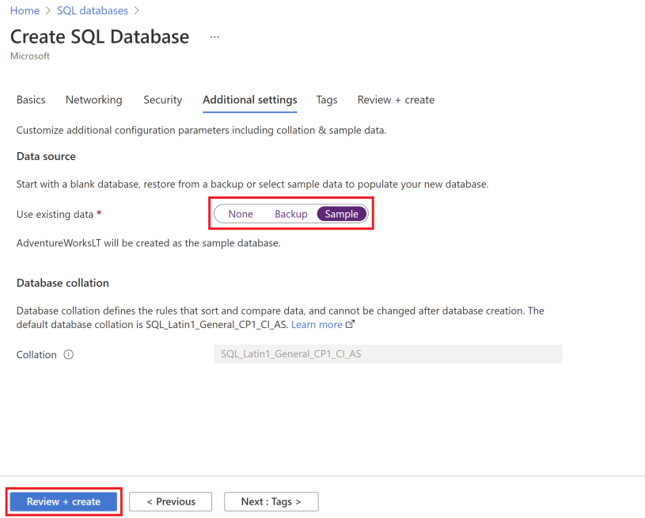

1. On the Review + create the page, after reviewing, select Create.

**Create a web app**

Sign in to the [Azure portal](https://portal.azure.com/learn.docs.microsoft.com) using the same account you used to activate the sandbox.

1. On the Azure portal menu, or from the Home page, select Create a resource. Everything you create on Azure is a resource. The Create a resource pane appears.  
   Here, you can search for the resource you want to create or select one of the popular resources that people create in the Azure portal.
2. In the Create a resource menu, select Web.
3. Select Web App. If you don't see it, in the search box, search for and select Web App. The Create Web App pane appears.
4. On the Basics tab, enter the following values for each setting.

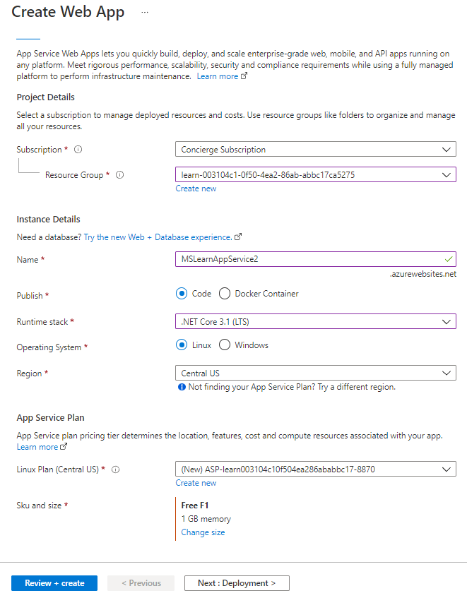

1. Select Review + Create to go to the preview pane, and then select Create. The portal shows the deployment pane, where you can view the status of your deployment.

Note: It can take a minute for deployment to complete.

#### Preview your web app

1. When the deployment is complete, select Go to the resource. The portal shows the App Service Overview pane for your web app.

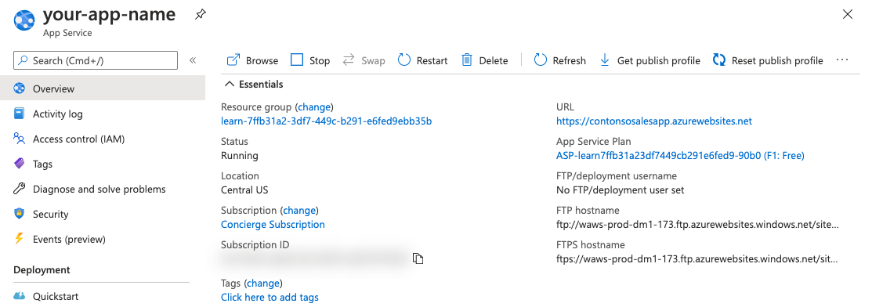

1. To preview your web app's default content, select the URL at the top right.

Create a Log Analytics workspaces

Use the Log Analytics workspaces menu to create a workspace.

1. In the [Azure portal](https://portal.azure.com/), enter Log Analytics in the search box. As you begin typing, the list filters based on your input. Select Log Analytics workspaces.

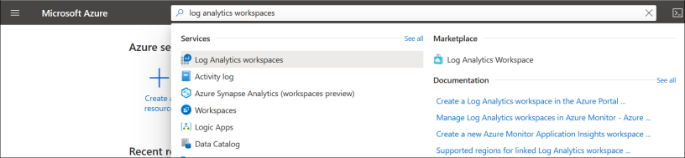

1. Select Add.
2. Select a Subscription from the dropdown.
3. Use an existing Resource Group or create a new one.
4. Provide a name for the new Log Analytics workspace, such as DefaultLAWorkspace. This name must be unique per resource group.
5. Select an available Region. For more information, see which [regions Log Analytics is available in](https://azure.microsoft.com/regions/services/). Search for Azure Monitor in the Search for a product box.

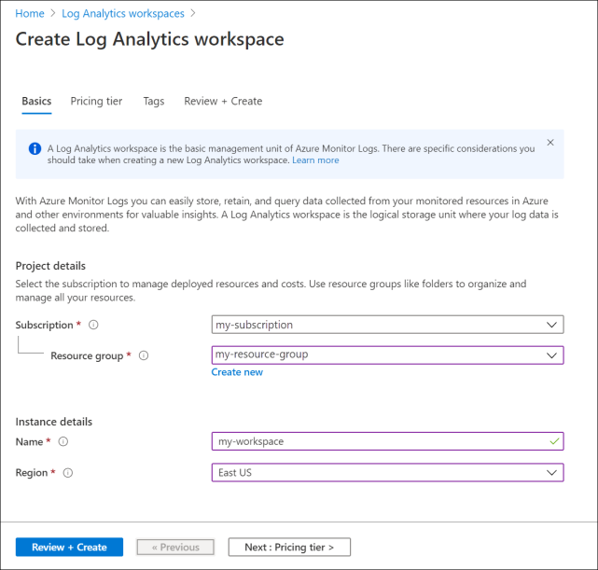

1. Select Review + Create to review the settings. Then select Create to create the workspace. A default pricing tier of pay-as-you-go is applied. No charges will be incurred until you start collecting enough data.

**Create an Application Insights resource**

1. Sign in to the [Azure portal](https://portal.azure.com/), and create an Application Insights resource:

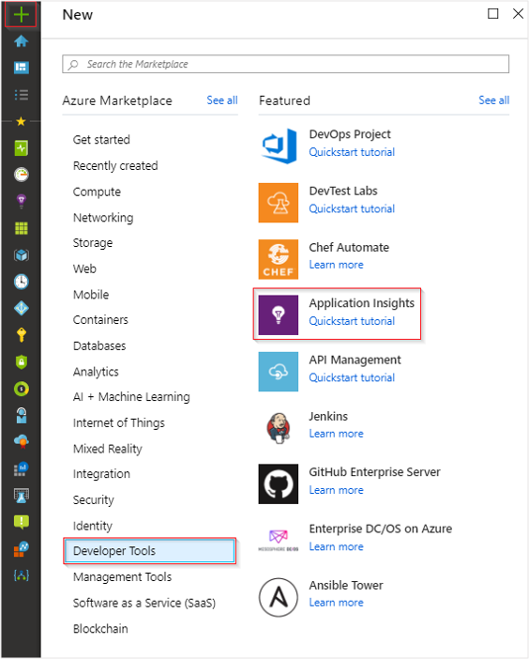

1. Note: While you can use the same resource name across different resource groups, it can be beneficial to use a globally unique name. This can be useful if you plan to [perform cross-resource](https://docs.microsoft.com/en-us/azure/azure-monitor/logs/cross-workspace-query#identifying-an-application) [queries](https://docs.microsoft.com/en-us/azure/azure-monitor/logs/cross-workspace-query#identifying-an-application) as it simplifies the required syntax.
2. Enter the appropriate values into the required fields, and then select Review + create.

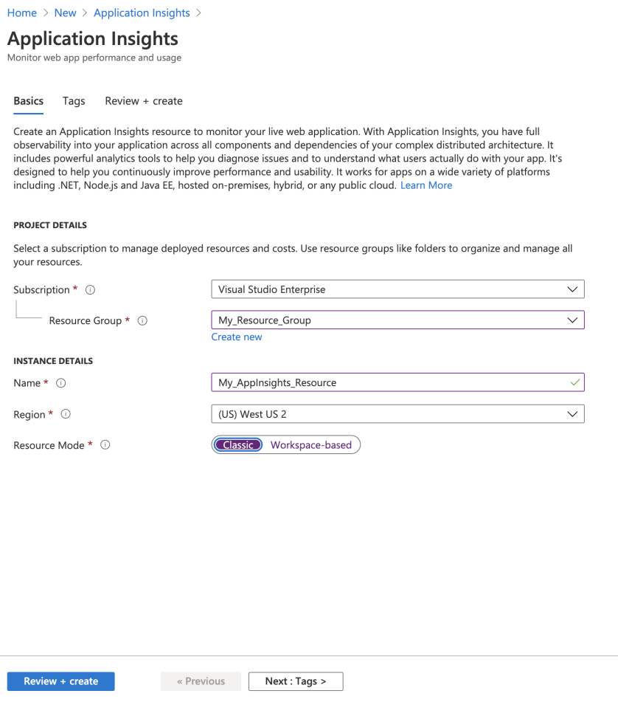

1. When your app has been created, a new pane opens. This pane is where you see performance and usage data about your monitored application.

## **4.2** **Database Design and Setup**

The database design maps the logical data model to the target database management system with consideration to the system’s performance requirements.

In SPITECH application database is designed using **3-Tier architecture**. In this architecture the client cannot directly communicate with the database. The client can communicate only with client application, server application and API’s (Microservices) can communicate the with database.

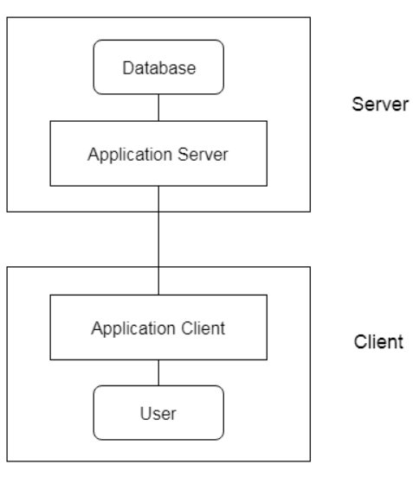

* **User**

An individual who uses the SpiTech Application.

* **Application Client**

Client application also known as user interface or presentation layer where a user enters his details required by UI.

* **Application Server**

An application where all logics and business rules are written and this application directly communicates with database.

* **Database**

Database stores all details enter by a user and all logic and business rules perform by server application.

SPITECH has 11 Databases representing 11 Microservices respectively.

|  |  |  |
| --- | --- | --- |
| **S.No.** | **DATABASE NAME (UAT)** | **DATABASE NAME (Production)** |
| 1 | Prod_Account | Prod_Account |
| 2 | Prod_EventNotification | Prod_EventNotification |
| 3 | Prod_Finance | Prod_Finance |
| 4 | Prod_HelpSupport | Prod_HelpSupport |
| 5 | Prod_IdentityServer | Prod_IdentityServer |
| 6 | Prod_Marketing | Prod_Marketing |
| 7 | Prod_MPPA | Prod_MPPA |
| 8 | Prod_PaymentGateWay | Prod_PaymentGateWay |
| 9 | Prod_Reports | Prod_Reports |
| 10 | Prod_Store | Prod_Store |
| 11 | Prod_Transaction | Prod_Transaction |

* + - 1. **Account Database - contains Business App Data tables (Send and Receive Invoice)**

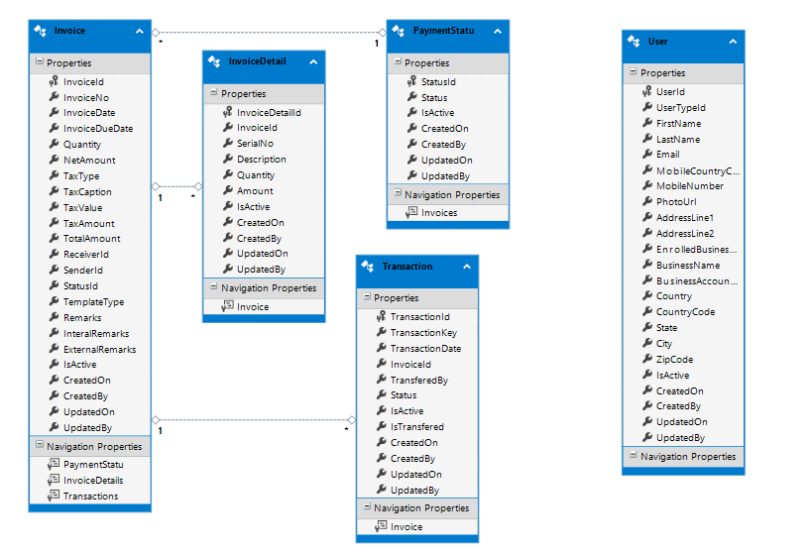

* + - 1. **Finance Database – contains data tables for Cash Reward (Debit / Credit)**

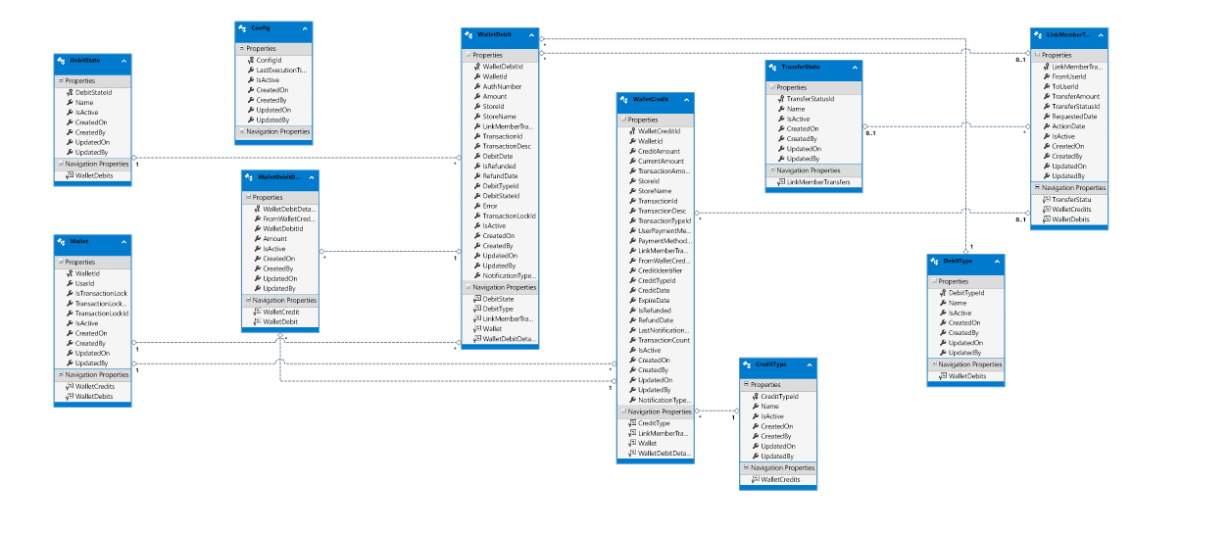

* + - 1. **Help & Support – contains data tables related to Tutorials , Support Email and phone numbers.**

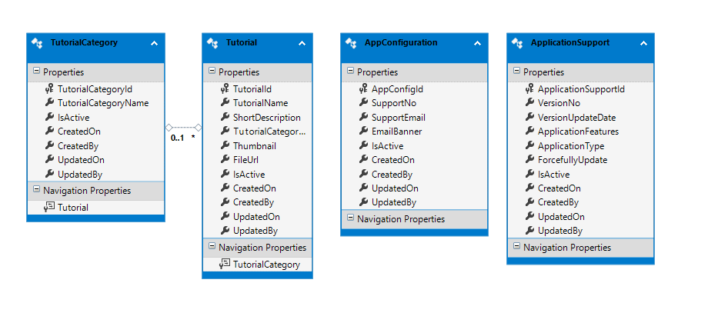

* + - 1. **Identity Server Database – contains data tables of user & authentication, etc.**

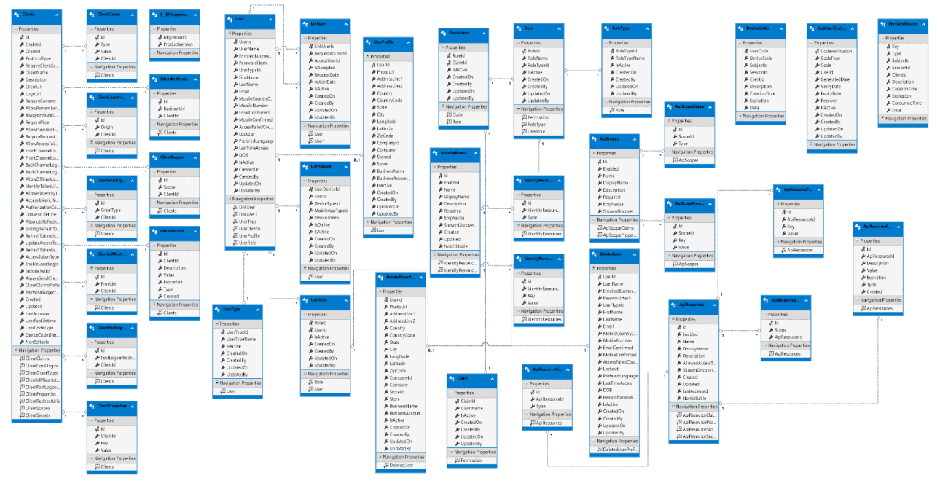

* + - 1. **Marketing Database – contains data tables related to Offers and Deals, Promotion, etc.**

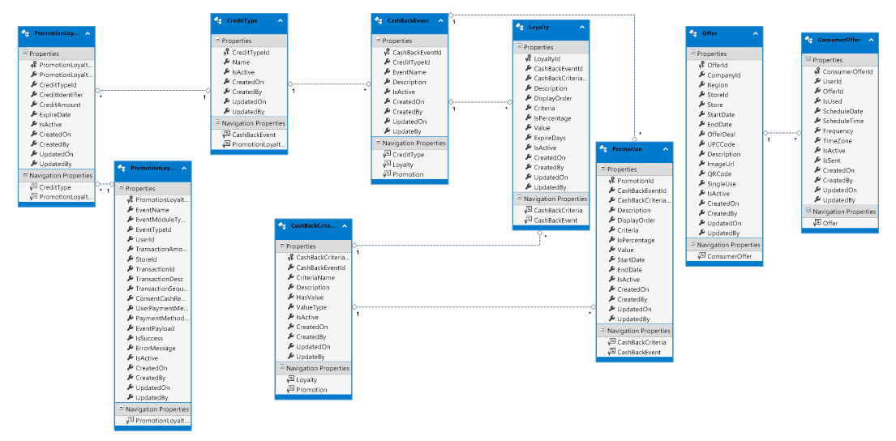

* + - 1. **MPPA – contains data tables related to Site controller, services and messages.**

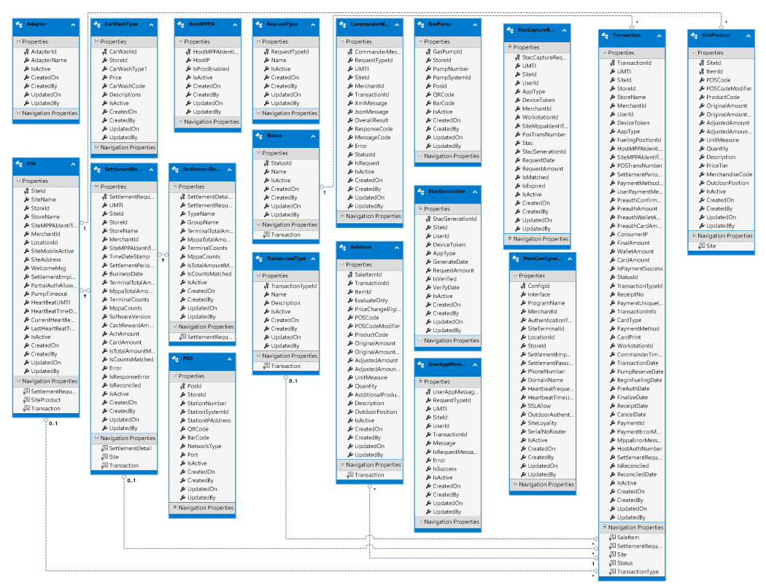

* + - 1. **Notification Database – contains data tables related to Notification – sms, email, push notifications, etc.**

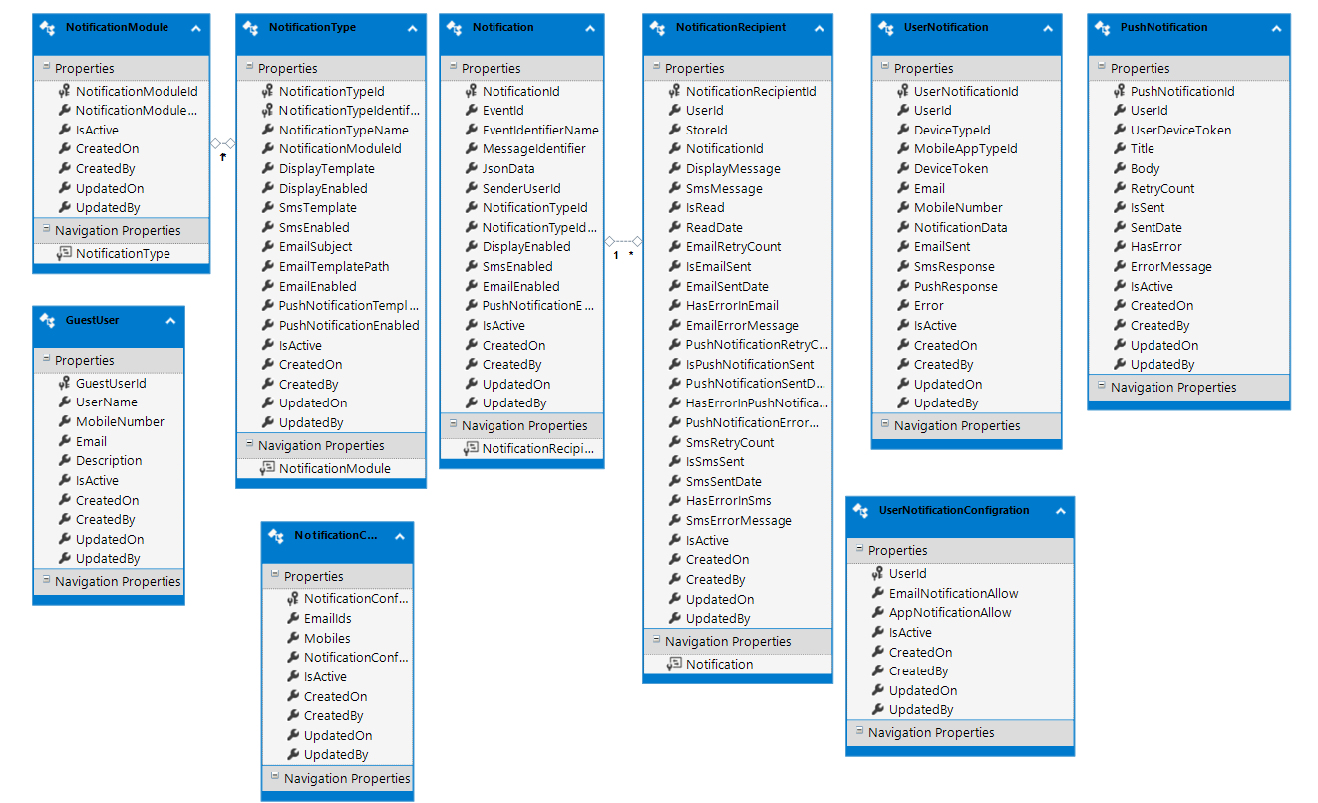

* + - 1. **Payment Gateway – contains data tables related to payment gateway configurations and processing.**

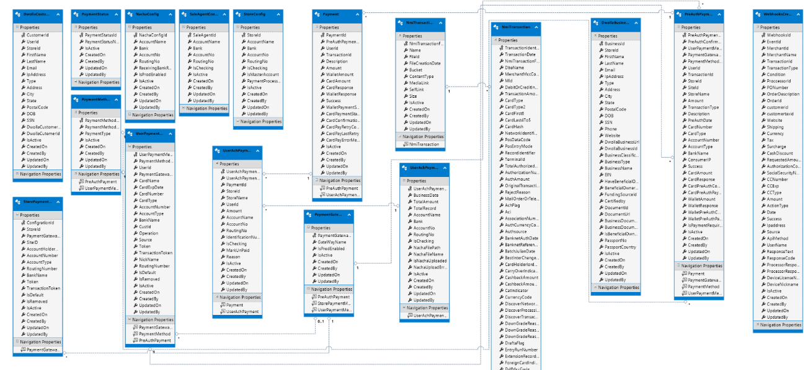

* + - 1. **Reports Database – Contains common reporting data tables.**

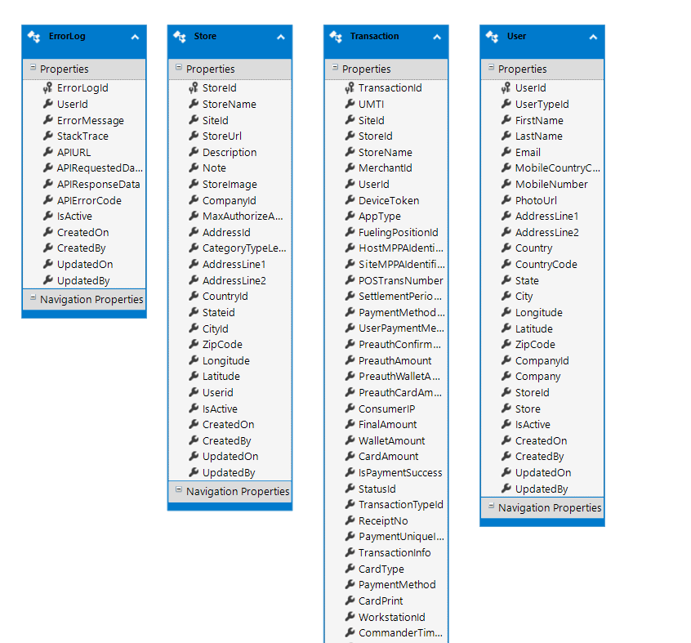

* + - 1. **Store Database – Contains data tables for Company Owners, Stores, Store Amenity, etc.**

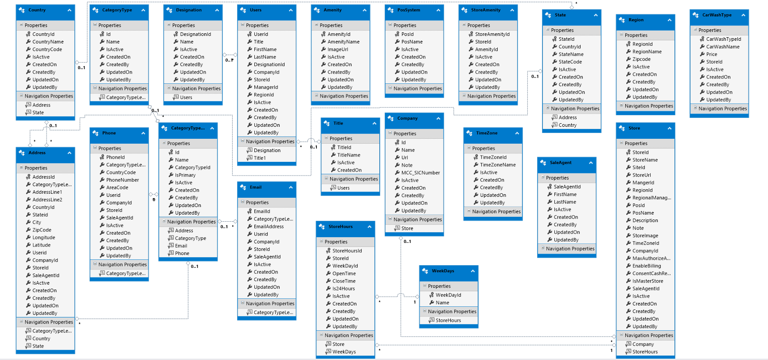

* + - 1. **Transaction Database – contains data tables for all transactions done in SPITECH application.**

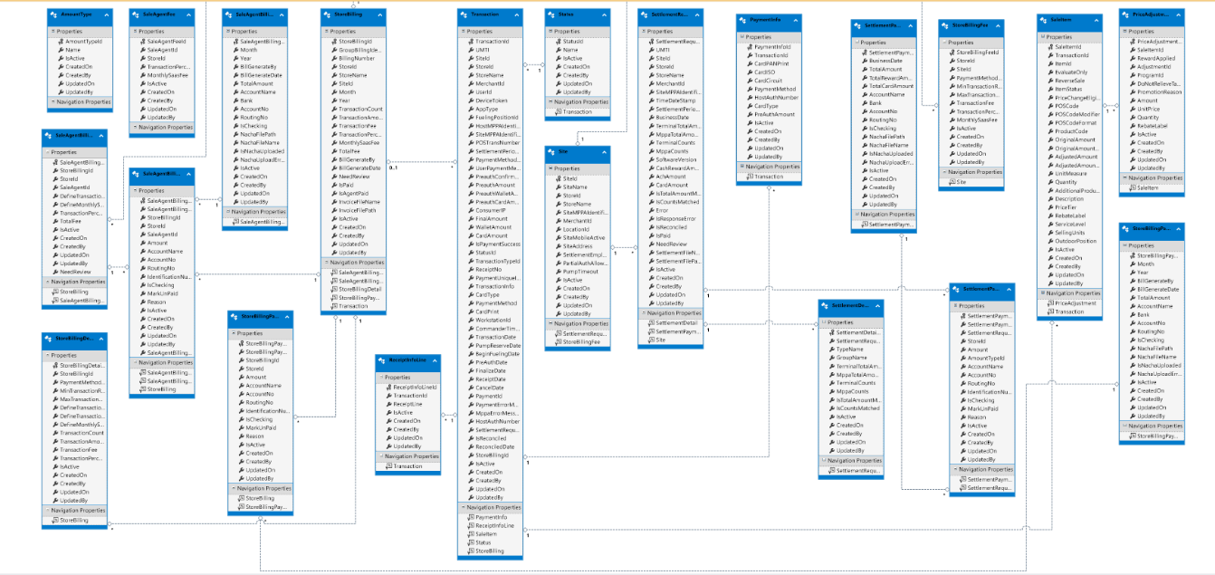

# **SpiTech API Specifications**

## **5.1** **Overview of API**

REST APIs (which are a type of web API) involve requests and responses, not too unlike visiting a web page. You make a request to a resource stored on a server, and the server responds with the requested information. The protocol used to transport the data is HTTP. “REST” stands for Representational State Transfer.

API Application hold the Dotnet API controller which is expose as rest API interface to client to execute Business operation on domain over wire, with http protocol. The data is provided as JSON format to client.

**Base Url (Development Environment): https://mobile.papipayllc.com/**

## **5.2** **Authentication**

Authentication, simply put, is proving that you are who you say you are. This is often confused with authorization, or the act of proving you are allowed to do what you’re requesting, but ultimately, authentication is a means of “logging in” to the interface. Authentication is key to many systems that handle rights management.

The implementation of identity is based on Dotnet core 5.0 with Microsoft Identity Server. The Identity is claim based with JWT token. Which need client credential to authorize to access the resources.

Using something like a [JWT](https://nordicapis.com/why-cant-i-just-send-jwts-without-oauth/), or **JSON Web Token**, can provide not only authentication, but a secure signature that is often passed as an entirely encoded package. This package can then easily be encrypted using something like JOSE, or the JSON Object Signing and Encryption library, to create a secure methodology.

**HTTP Call Type Definitions**

Any web API will interact with the various HTTP call methods, and as such, documenting which methods are used and how they are used within your API is going to be extremely important.

Common call type verbiage that should be defined and discussed is listed below.

**GET -** Typically used to retrieve a representation of a resource, GET is going to be one of the most commonly used verbs for most APIs. As such, documentation should delve into exactly what GET is used for in the API, what resources can be called, and what limitations on this functionality are in place.

**POST -** Less commonly used by the average user than GET, POST is a method of submit an entity to the resource, and typically results in a change of state. POST is still commonly used, and as such, should be considered secondary in importance to GET, yet treated with the importance it deserves.

**PUT -** PUT is essentially a method for updating or replacing an entry. Accordingly, this function will be limited to authorized users in most implementations, and as such, may not be applicable for the entire user base. How PUT functions and what entries are changeable should be well-documented.

**PATCH ­-** Used for updating or modifying an entry, PATCH is going to be similarly limited like PUT, though in some implementations it might be used to modify specific entries that are unique to the user – in this case, documentation for how that is done should differentiate between the two.

**DELETE -** Delete is specifically used to delete an entry, and as such, is often heavily limited in its use and requires higher rights to utilize. Accordingly, while the use of DELETE may not be something that should be documented extensively, the limitations of user classes should definitely reference this verbiage and whether or not it is something the average user will have to be concerned with.

## **5.3** **Pay at Pump**

This section provides details on the messages and elements used in SPITECH Mobile API for messages sent between the SPITECH Mobile Application and the SPITECH MPPA for doing a pay at pump transaction.

### 5.3.1 Login

|  |  |  |  |
| --- | --- | --- | --- |
| Name | Base URL | API | Request |
| SignUp | baseURL.identityBaseUrl + "api/" | "AccountUser/ConsumerRegister" | {  "mobileCountryCode": "string",  "mobileNumber": "string",  "email": "string",  "deviceToken": "string",  "deviceType": 0,  "password": "string",  "firstName": "string",  "lastName": "string",  "preferedLanguage": "string",  "addressLine1": "string",  "addressLine2": "string",  "country": "string",  "countryCode": "string",  "state": "string",  "city": "string",  "longitude": "string",  "latitude": "string",  "zipCode": "string",  "dob": "string"  } |
| UserLogin | baseURL.identityBaseUrl | "connect/token" | grant_type:”password", "username": emailTextField.text!, “password”:passwordText.text!, "scope": baseURL.scopes, "client_id": baseURL.clientId, “client_secret":baseURL.clientSecret |
| GetUserData | baseURL.identityBaseUrl + "api/" | "AccountUser/GetUserFromtoken" |  |
| UpdateDeviceToken | baseURL.identityBaseUrl + "api/" | "AccountUser/UpdateUserDevice" | {  "userId": 0,  "deviceToken": "string",  "deviceType": 0,  "mobileAppType": "None"  } |
| User Verification - To verify mobile generate OTP | baseURL.identityBaseUrl + "api/AccountUser" | "/GenerateMobileCode" | {  "userType": "None",  "mobileCountryCode": "string",  "mobileNumber": "string"  } |
| User Verification - Verify OTP | baseURL.identityBaseUrl + "api/" | "AccountUser/VerifyMobile" | {  "userType": "None",  "mobileCountryCode": "string",  "mobileNumber": "string",  "verificationCode": "string"  } |

### 5.3.2 Home Screen

|  |  |  |  |
| --- | --- | --- | --- |
| Home Screen - stores list To Get | baseURL.mobileBaseUrl + "stores/" | "api/Stores/StoreSummary" | {  "pageIndex": 0,  "pageSize": 0,  "totalCount": 0,  "totalPages": 0,  "data": [  {  "storeId": 0,  "storeName": "string",  "siteId": "string",  "maxAuthorizeAmount": 0,  "consentCashReward": true,  "distance": 0,  "addresses": [  {  "addressId": 0,  "categoryTypeLevelId": 0,  "addressLine1": "string",  "addressLine2": "string",  "longitude": 0,  "latitude": 0,  "zipCode": "string",  "storeId": 0  }  ],  "pumpProducts": [  {  "siteId": "string",  "originalAmountUnitPrice": 0,  "unitMeasure": "string",  "description": "string",  "priceTier": "string"  }  ]  }  ],  } |
| Home Screen - To Get store Amenity | baseURL.mobileBaseUrl + "stores/" | "api/Amenity" | {  "data": [  {  "amenityId": 0,  "amenityName": "string",  "imageUrl": "string"  }  ]  } |
| Home Screen - To get user’s wallet amount | baseURL.mobileBaseUrl + "finances/api" | “/Wallet/GetUserWallet?UserId=UserID | {  "success": true,  "message": "string",  "data": {  "walletId": 0,  "userId": 0,  "isTransactionLock": true,  "transactionLockOn": "2022-10-06T10:30:47.942Z",  "transactionLockId": "string",  "totalCreditAmount": 0,  "totalRedeemAmount": 0,  "totalAvailableAmount": 0,  "totalTransferAmount": 0,  "totalRecentExpiredAmount": 0  }  } |
| Home Screen - To Get store Amenity | baseURL.mobileBaseUrl + "stores/" | "api/Amenity" | {  "data": [  {  "amenityId": 0,  "amenityName": "string",  "imageUrl": "string"  }  ]  } |
| Home Screen - To get unread notification count | baseURL.mobileBaseUrl + "notifications/api" | “/Notifications/unread-count?UserId=UserId" | 0 |

### 5.3.3 Add Payment Method

|  |  |  |  |
| --- | --- | --- | --- |
| Add Card | baseURL.mobileBaseUrl + "payments/" | "api/Payment/AddCard/1” | Parameters - ["client_id": "62177b634de41c001bc8d33f", "products": ["auth"], "country_codes": ["US"], "user": ["client_user_id": "76"], "client_name": " SPITECH", "secret": "6a04e8ff5ab8536918a86f152c4d6a", "language": "en"] |
| To get list of cards | baseURL.mobileBaseUrl + "payments/" | "api/Payment/UserPaymentMethod | {  "data": [  {  "userPaymentMethodId": 0,  "paymentMethodId": 0,  "paymentGatewayConfigId": 0,  "userId": 0,  "cardName": "string",  "cardExpDate": "string",  "cardNumber": "string",  "cardType": "string",  "accountNumber": "string",  "accountType": "string",  "bankName": "string",  "custId": "string",  "operation": "string",  "source": "string",  "token": "string",  "transactionToken": "string",  "nickName": "string",  "routingNumber": "string",  "isDefault": true,  "isRemoved": true  }  ]  } |
| To Delete card | baseURL.mobileBaseUrl + "payments/" | "api/Payment/DeleteUserPaymentMethod?UserPaymentMethodId=" | {  "success": true,  "message": "string"  } |
| FinalReceipt |  |  | {"receiptData":{"transaction":{"transactionId":7194.0,"umti":"PPMU0000000007194","siteId":"L340820196001","storeId":2.0,"storeName":"Chip\u0027s Quik Stop - Gilbarco","merchantId":"820196","userId":27.0,"deviceToken":"","appType":"Android","fuelingPositionId":1.0,"hostMPPAIdentifier":"01","posTransNumber":"318386","settlementPeriodId":"000010","userPaymentMethodId":1.0,"preauthConfirmationNo":"02203a875b894794b4d210365fc5aab3","preauthAmount":0.9,"preauthWalletAmount":0.0,"preauthCardAmount":0.9,"finalAmount":0.0,"walletAmount":0.0,"cardAmount":0.0,"isPaymentSuccess":true,"statusId":2.0,"transactionTypeId":1.0,"transactionInfo":"Fuel","cardType":"amex","paymentMethod":"Credit","cardPrint":"378348*****1322","commanderTimeDateStamp":"2022-04-29T02:19:44.569","transactionDate":"2022-04-29T07:17:59.11","isReconciled":false,"pumpReserveDate":"2022-04-29T07:17:59.11","beginFuelingDate":"2022-04-29T07:18:19.88","preAuthDate":"2022-04-29T07:18:19.13","finalizeDate":"2022-04-29T07:18:31.2365115Z","hostAuthNumber":"01"},"paymentInfo":{"cardPANPrint":"Credit","cardISO":"378348*****1322","paymentMethod":"Credit","hostAuthNumber":"01","cardType":"amex","preAuthAmount":0.9},"siteName":"PETRO PROS LAB ","siteAddress":"1408 S FRETZ AVE |EDMOND |OK|73003","tax":0.0,"subTotal":0.0,"total":0.0,"receiptInfoLines":[]}} |

### 5.3.4 Signal R Connections for Pay at Pump

|  |  |  |  |
| --- | --- | --- | --- |
| FOR SINGNAL R CONNECTION – Base URL = ws://20.83.32.86:30789/mppahub?access_token=”” | | | |
| METHOD | REQUEST | RESPONSE | PURPOSE |
| PumpReserveRequest | {"cardAmount":10.0,"deviceToken":,"deviceType":1,"fuelingPositionId":1,"siteId":"5435453453","userPaymentMethodId":182,"walletAmount":0.0} |  |  |
| PumpReserveResponse |  | {"umti":"7779c5d5-c37e-4a86-96b9-9f016f79219b","userId":11,"siteId":"497231540889","fuelingPositionId":1,"status":"ReserveInprogress","success":true,"erorr":""} |  |
| ProcessStatusResponse |  | {"umti":"7779c5d5-c37e-4a86-96b9-9f016f79219b","userId":11,"siteId":"497231540889","fuelingPositionId":1,"status":"ReserveSuccess","success":true,"erorr":""} |  |
| ProcessStatusResponse |  | {"umti":"7779c5d5-c37e-4a86-96b9-9f016f79219b","userId":11,"siteId":"497231540889","fuelingPositionId":1,"status":"AuthSuccess","processName":"Auth","success":true,"erorr":""} | ”OnError” ( when something goes wrong) |
| PumpReserveCancelRequest |  |  | We can cancel pump process by invoking this request |
| PumpBeginFual |  | {"userId":11,"beginFuel":true,"beginFuelMessage":"Fueling Started"} |  |
| FinalizesData |  | {"receiptData":{"transaction":{"transactionId":7194.0,"umti":"PPMU0000000007194","siteId":"L340820196001","storeId":2.0,"storeName":"Chip\u0027s Quik Stop - Gilbarco","merchantId":"820196","userId":27.0,"deviceToken":””,"appType":"Android","fuelingPositionId":1.0,"hostMPPAIdentifier":"01","posTransNumber":"318386","settlementPeriodId":"000010","userPaymentMethodId":1.0,"preauthConfirmationNo":"02203a875b894794b4d210365fc5aab3","preauthAmount":0.9,"preauthWalletAmount":0.0,"preauthCardAmount":0.9,"finalAmount":0.0,"walletAmount":0.0,"cardAmount":0.0,"isPaymentSuccess":true,"statusId":2.0,"transactionTypeId":1.0,"transactionInfo":"Fuel","cardType":"amex","paymentMethod":"Credit","cardPrint":"378348*****1322","commanderTimeDateStamp":"2022-04- 29T02:19:44.569","transactionDate":"2022-04-29T07:17:59.11","isReconciled":false,"pumpReserveDate":"2022-04-29T07:17:59.11","beginFuelingDate":"2022-04-29T07:18:19.88","preAuthDate":"2022-04-29T07:18:19.13","finalizeDate":"2022-04-29T07:18:31.2365115Z","hostAuthNumber":"01"},"paymentInfo":{"cardPANPrint":"Credit","cardISO":"378348*****1322","paymentMethod":"Credit","hostAuthNumber":"01","cardType":"amex","preAuthAmount":0.9},"siteName":"PETRO PROS LAB ","siteAddress":"1408 S FRETZ AVE |EDMOND |OK|73003","tax":0.0,"subTotal":0.0,"total":0.0,"receiptInfoLines":[]}} |  |

### 5.3.5 Transaction and Cash Reward History

|  |  |  |  |
| --- | --- | --- | --- |
| Name | Base URL | API | Request |
| Transaction History | baseURL.mobileBaseUrl + "reports/api" | "/Transaction" | "?UserId=\(User.UserId)\(self.filterStr)&pageSize=\(pageSize)&pageIndex=\(self.currentIndex)&Storename=\(searchTextField.text!)" |
| Transaction History Receipt | baseURL.mobileBaseUrl + "transactions/api" | "/Transaction/Receipt" | "?TransactionId=\(transactionId)" |
| Transaction History Cash Rewards | baseURL.mobileBaseUrl + "finances/api" | "/Wallet/GetWalletCreditByTransactionId" | "?TransactionId=\(transactionId)" |
| Get notifications | baseURL.mobileBaseUrl + "notifications/api" | "/Notifications?UserId=" | "\(User.UserId)&PageSize=\(pageSize)&PageIndex=\(currentIndex)" |
| mark notification as read | baseURL.mobileBaseUrl + "notifications/api" | "/Notifications/mark-read" | {  "userId": 0,  "notificationRecipientIds": [  0  ]  } |
| To get receipt data of a transaction | baseURL.mobileBaseUrl + "transactions/api" | "/Transaction/Receipt" | "?TransactionId=\(transactionId)" |
| To Get offers | baseURL.mobileBaseUrl + "marketing/api" | "/Offer/ByFilter" | {  "pageIndex": 0,  "pageSize": 0,  "totalCount": 0,  "totalPages": 0,  "data": [  {  "offerId": 0,  "companyId": 0,  "region": 0,  "storeId": 0,  "store": "string",  "startDate": "2022-10-06T11:36:30.193Z",  "endDate": "2022-10-06T11:36:30.193Z",  "offerDeal": "string",  "upcCode": "string",  "description": "string",  "imageUrl": "string",  "qrCode": true,  "singleUse": true  }  ],  "hasPreviousPage": true,  "hasNextPage": true  } |
| To search offer by store name | baseURL.mobileBaseUrl + "marketing/api" | “/Offer/SearchByFilter?StoreName=(StoreName)” | {  "data": [  {  "offerId": 0,  "companyId": 0,  "region": 0,  "storeId": 0,  "store": "string",  "startDate": "2022-10-06T11:37:39.955Z",  "endDate": "2022-10-06T11:37:39.955Z",  "offerDeal": "string",  "upcCode": "string",  "description": "string",  "imageUrl": "string",  "qrCode": true,  "singleUse": true  }  ]  } |
| To get Linked user | baseURL.identityBaseUrl + "api/LinkUser" | "/Get?UserId=" | UserId |
| To generate QR code | baseURL.identityBaseUrl + "api/LinkUser" | "/GenerateCode?userId=\(User.UserId)" | [ "userId": Int(User.UserId)!  ] |
| To Link User request | baseURL.identityBaseUrl + "api/LinkUser" | "/Request" | {  "requestedUserId": 0,  "linkUserCode": "string"  } |
| To remove linked user | baseURL.identityBaseUrl + "api/LinkUser" | "/Remove" | {  "fromUserId": 0,  "toUserId": 0  } |
| To transfer wallet | baseURL.mobileBaseUrl + "finances/api" | "/Wallet/Transfer" | {  "fromUserId": 0,  "amount": 0,  "toUserId": 0  } |
| To request amount transfer | baseURL.mobileBaseUrl + "finances/api" | "/Wallet/RequestAmountTransfer" | {  "requestedUserId": 0,  "requestedAmount": 0,  "fromUserId": 0  } |
| Get pending amount transfer requests | baseURL.mobileBaseUrl + "finances/api" | "/Wallet/GetPendingAmountTransferRequestsByUserId?UserId=" | UserId |
| To Decline amount transfer | baseURL.mobileBaseUrl + "finances/api" | "/Wallet/DeclineAmountTransfer" | {  "linkMemberTransferId": 0  } |
| To Accept amount transfer request | baseURL.mobileBaseUrl + "finances/api" | "/Wallet/AcceptAmountTransferRequest" | {  "linkMemberTransferId": 0  } |
| To get wallet history | baseURL.mobileBaseUrl + "finances/api" | "/Wallet/GetWalletHistory?UserId=" | "\(User.UserId)&PageIndex=\(currentIndex)&PageSize=\(pageSize)" |

### 5.3.6 User Profile

|  |  |  |  |
| --- | --- | --- | --- |
| **Name** | **Base URL** | **API** | **Request** |
| To Update Mobile Number | baseURL.identityBaseUrl + "api/" | "AccountUser/UpdateMobileNumber" | {  "mobileCountryCode": "string",  "mobileNumber": "string",  "verificationCode": "string"  } |
| To Update Profile | baseURL.identityBaseUrl + "api/" | "AccountUser/UpdateProfile" | {  "userId": 0,  "firstName": "string",  "lastName": "string",  "email": "string",  "mobileCountryCode": "string",  "mobileNumber": "string",  "addressLine1": "string",  "addressLine2": "string",  "country": "string",  "countryCode": "string",  "state": "string",  "city": "string",  "longitude": "string",  "latitude": "string",  "zipCode": "string",  "companyId": 0,  "company": "string",  "storeId": 0,  "store": "string",  "photoUrlbase64": "string",  "dob": "string",  "deviceToken": "string",  "deviceType": 0,  "mobileAppType": "None",  "roleIds": [  0  ]  } |
| To get user data from token | baseURL.identityBaseUrl + "api/" | "AccountUser/GetUserFromtoken" |  |
| To Generate Email OTP | baseURL.identityBaseUrl + "api/AccountUser" | "/GenerateEmailCode" | {  "userId": 0  } |
| To Verify Email OTP | baseURL.identityBaseUrl + "api/" | "AccountUser/GenerateMobileUpdateVerificationCode" | {  "mobileCountryCode": "string",  "mobileNumber": "string"  } |
| To change password | baseURL.identityBaseUrl + "api/" | "AccountUser/ChangePassword" | {  "password": "string",  "newPassword": "string"  } |
| To Reset Password | baseURL.identityBaseUrl + "api/" | "AccountUser/ResetConsumerPassword" | {  "mobileCountryCode": "string",  "mobileNumber": "string",  "verificationCode": "string",  "password": "string"  } |

### 5.3.6 App Settings

|  |  |  |  |
| --- | --- | --- | --- |
| Name | Base URL | API | Request |
| To Get User notification configuratio | baseURL.mobileBaseUrl + "notifications/api" | "/UserNotificationConfigration/(User.UserId)" |  |
| To Update User Notification configuration | baseURL.mobileBaseUrl + "notifications/api" | "/UserNotificationConfigration" | {  "userId": 0,  "emailNotificationAllow": true,  "appNotificationAllow": true  } |
| To Update preferred language on server | baseURL.identityBaseUrl + "api/" | "AccountUser/UpdatePreferredLanguage" | {  "preferredLanguage": "string"  } |
| To Delete User Account | baseURL.identityBaseUrl + "api/" | "AccountUser/RemoveAccount" | {  "userId": 0,  "reasonforDeletion": "string"  } |

## **5.4** **Pay in Store**

|  |  |  |  |
| --- | --- | --- | --- |
| FOR SINGNAL R CONNECTION – Base URL = ws://20.83.32.86:30789/mppahub?access_token=”” | | | |
| PURPOSE | **METHOD** | **BASE URL** | **REQUEST / RESPONSE** |
| To Generate QR/Bar Code | StacGenerationRequest |  | {"deviceToken":"c51GUXcELWY:APA91bHl-pNVC9kc2Hl31SZb4Cbuzc-vWORx6CVy3QhO_6mHseqrliBIevVj81yrULTNn4tnG453V6nd7UjGFAhnb0A2x0HSHUizHXib4m8m1EoH6qr0ynKDoI_FbQ61nB_-I6FthxUN","deviceType":1,"siteId":"324342323"} |
|  | StacGenerationResponse |  | {"userId":8.0,"siteId":"324342323","stac":"PAP.81D3E17636F0473FA93FACEAD0C13D1E","generateDate":"2022-10-07T06:10:55.9566574Z","success":true,"erorr":""} |
|  | StacCaptureResponse |  | {"umti":"78976","userId":108.0,"siteId":"L340820196001","stac":"PAP.516131DD9D2A431F8224EAAD7755FE1C","captureDate":"2021-12-23T16:09:05.70977Z","isMatched":true,"isExpired":false,"success":true,"erorr":""} |
| To Authorise user for payment | PosTransactionAuthorize |  |  |
| PosTransactionDataProcess |  |  |  |
| ProcessStatusResponse |  |  | {"umti":"VFIMobile_2_173636","userId":108.0,"siteId":"497231540889","status":"AuthSuccess","processName":"Auth","success":true,"erorr":""} |
| FinalizesData |  |  | {"receiptData":{"transaction":{"transactionId":957.0,"umti":"VFIMobile_2_173636","siteId":"497231540889","merchantId":"686657","userId":108.0,"deviceToken":"","siteMPPAIdentifier":"2","posTransNumber":"1010124","settlementPeriodId":"20211206.002","userPaymentMethodId":2.0,"preauthConfirmationNo":"309be9b72dce","preauthAmount":26.85,"finalAmount":26.85,"isPaymentSuccess":true,"statusId":2.0,"transactionTypeId":3.0,"workstationId":"POS001","commanderTimeDateStamp":"2021-12-27T23:42:18.139-06:00","transactionDate":"2021-12-28T05:41:10.923","isReconciled":false,"pumpReserveDate":"2021-12-28T05:41:10.923","preAuthDate":"2021-12-28T05:41:25.227","finalizeDate":"2021-12-28T05:41:57.3727258Z","hostAuthNumber":"01"},"paymentInfo":{"cardPANPrint":"6667","paymentMethod":"Cash","hostAuthNumber":"01","cardType":"PC","preAuthAmount":0.0},"siteName":"LAB","siteAddress":"14808 SANTA FE CROSSING DR","tax":7.105427357601002E-15,"subTotal":26.849999999999994,"total":26.85,"saleItems":[{"itemID":1.0,"evaluateOnly":false,"itemStatus":false,"priceChangeEligible":false,"posCode":"00025725050109","posCodeModifier":"0","posCodeFormat":"plu","productCode":"400","originalAmount":6.99,"originalAmountUnitPrice":6.99,"adjustedAmount":6.99,"adjustedAmountUnitPrice":6.99,"unitMeasure":"EA","quantity":1.0,"additionalProductInfo":"A FOOTBALL","description":"A FOOTBALL","outdoorPosition":0.0},{"itemID":2.0,"evaluateOnly":false,"itemStatus":false,"priceChangeEligible":false,"posCode":"00025725050109","posCodeModifier":"0","posCodeFormat":"plu","productCode":"400","originalAmount":6.99,"originalAmountUnitPrice":6.99,"adjustedAmount":6.99,"adjustedAmountUnitPrice":6.99,"unitMeasure":"EA","quantity":1.0,"additionalProductInfo":"A FOOTBALL","description":"A FOOTBALL","outdoorPosition":0.0},{"itemID":3.0,"evaluateOnly":false,"itemStatus":false,"priceChangeEligible":false,"posCode":"00025725050109","posCodeModifier":"0","posCodeFormat":"plu","productCode":"400","originalAmount":6.99,"originalAmountUnitPrice":6.99,"adjustedAmount":6.99,"adjustedAmountUnitPrice":6.99,"unitMeasure":"EA","quantity":1.0,"additionalProductInfo":"A FOOTBALL","description":"A FOOTBALL","outdoorPosition":0.0},{"itemID":4.0,"evaluateOnly":false,"itemStatus":false,"priceChangeEligible":false,"posCode":"00047995855239","posCodeModifier":"0","posCodeFormat":"plu","productCode":"400","originalAmount":0.99,"originalAmountUnitPrice":0.99,"adjustedAmount":0.99,"adjustedAmountUnitPrice":0.99,"unitMeasure":"EA","quantity":1.0,"additionalProductInfo":"AMERICAN SPIRIT ORANGE","description":"AMERICAN SPIRIT ORANGE","outdoorPosition":0.0},{"itemID":5.0,"evaluateOnly":false,"itemStatus":false,"priceChangeEligible":false,"posCode":"00047995855239","posCodeModifier":"0","posCodeFormat":"plu","productCode":"400","originalAmount":0.99,"originalAmountUnitPrice":0.99,"adjustedAmount":0.99,"adjustedAmountUnitPrice":0.99,"unitMeasure":"EA","quantity":1.0,"additionalProductInfo":"AMERICAN SPIRIT ORANGE","description":"AMERICAN SPIRIT ORANGE","outdoorPosition":0.0},{"itemID":6.0,"evaluateOnly":false,"itemStatus":false,"priceChangeEligible":false,"posCode":"00047995855239","posCodeModifier":"0","posCodeFormat":"plu","productCode":"400","originalAmount":0.99,"originalAmountUnitPrice":0.99,"adjustedAmount":0.99,"adjustedAmountUnitPrice":0.99,"unitMeasure":"EA","quantity":1.0,"additionalProductInfo":"AMERICAN SPIRIT ORANGE","description":"AMERICAN SPIRIT ORANGE","outdoorPosition":0.0},{"itemID":7.0,"evaluateOnly":false,"itemStatus":false,"priceChangeEligible":false,"posCode":"00000000000000","posCodeModifier":"000","posCodeFormat":"plu","productCode":"950","originalAmount":2.91,"originalAmountUnitPrice":2.91,"adjustedAmount":2.91,"adjustedAmountUnitPrice":2.91,"unitMeasure":"EA","quantity":1.0,"additionalProductInfo":"Tax","description":"Tax","outdoorPosition":0.0}],"receiptInfoLines":[]}} |
| FinalReceipt |  |  | {"receiptData":{"transaction":{"transactionId":1020.0,"umti":"89719","siteId":"L340820196001","merchantId":"820196","userId":1194.0,"deviceToken":"","posTransNumber":"89719","settlementPeriodId":"000003","userPaymentMethodId":2.0,"preauthConfirmationNo":"b8d0a90dfcee","preauthAmount":9.84,"finalAmount":9.84,"isPaymentSuccess":true,"statusId":2.0,"transactionTypeId":3.0,"workstationId":"1","commanderTimeDateStamp":"2021-12-29T00:02:34.851","transactionDate":"2021-12-29T06:02:07.27","isReconciled":false,"pumpReserveDate":"2021-12-29T06:02:07.27","preAuthDate":"2021-12-29T06:02:25.3","finalizeDate":"2021-12-29T06:02:28.7056268Z","hostAuthNumber":"01"},"paymentInfo":{"paymentMethod":"Cash","hostAuthNumber":"01","preAuthAmount":0.0},"siteName":"PETRO PROS LAB ","siteAddress":"1408 S FRETZ AVE |EDMOND |OK|73003","tax":0.85,"subTotal":8.99,"total":9.84,"saleItems":[{"itemID":1.0,"evaluateOnly":false,"itemStatus":true,"priceChangeEligible":false,"posCode":"","posCodeModifier":"","productCode":"400","originalAmount":8.99,"originalAmountUnitPrice":8.99,"adjustedAmount":8.99,"adjustedAmountUnitPrice":8.99,"quantity":1.0,"description":"Dept 1","outdoorPosition":0.0},{"itemID":2.0,"evaluateOnly":false,"itemStatus":true,"priceChangeEligible":true,"posCode":"950","posCodeModifier":"000","posCodeFormat":"plu","productCode":"950","originalAmount":0.85,"originalAmountUnitPrice":0.85,"adjustedAmount":0.85,"adjustedAmountUnitPrice":0.85,"quantity":1.0,"description":"Tax","outdoorPosition":0.0}],"receiptInfoLines":[]}} |